



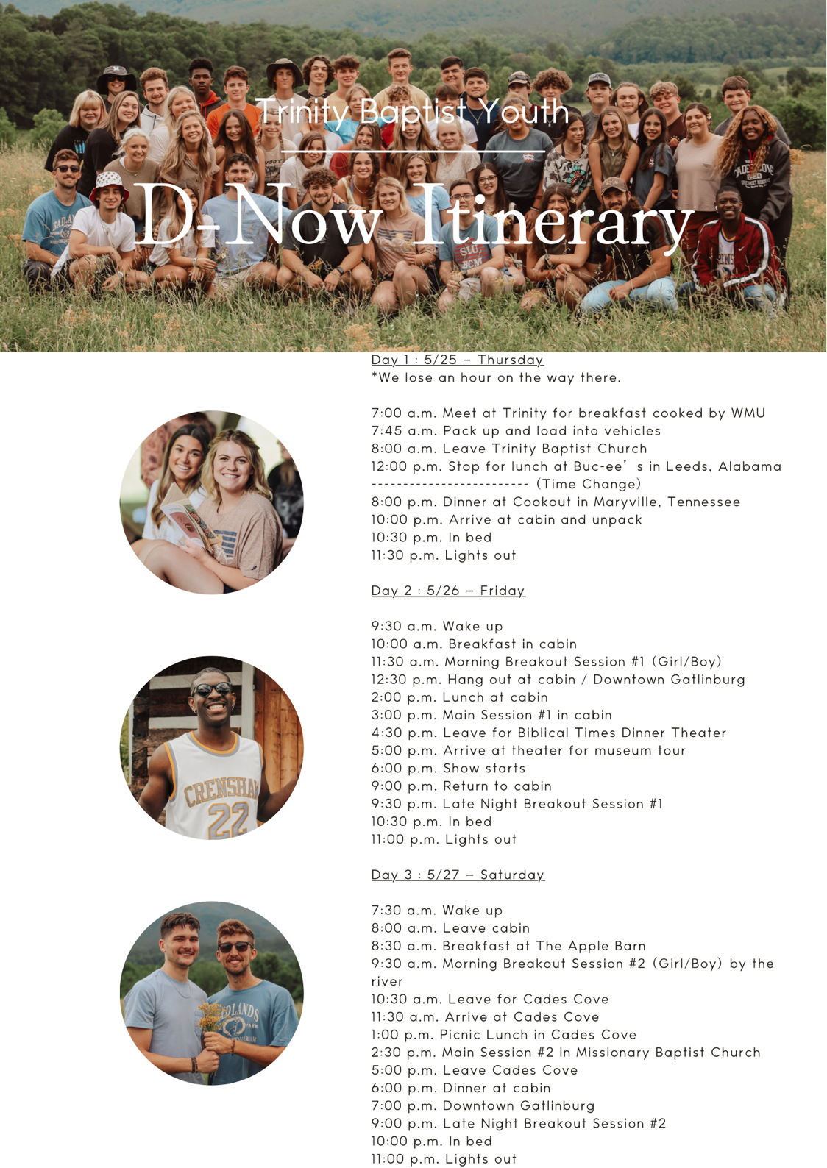

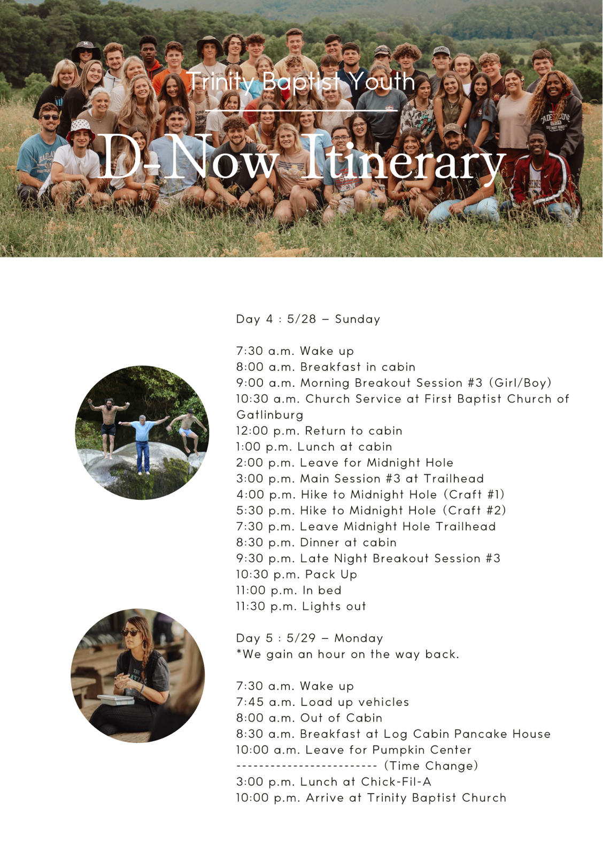





Day 1 Memory Verse
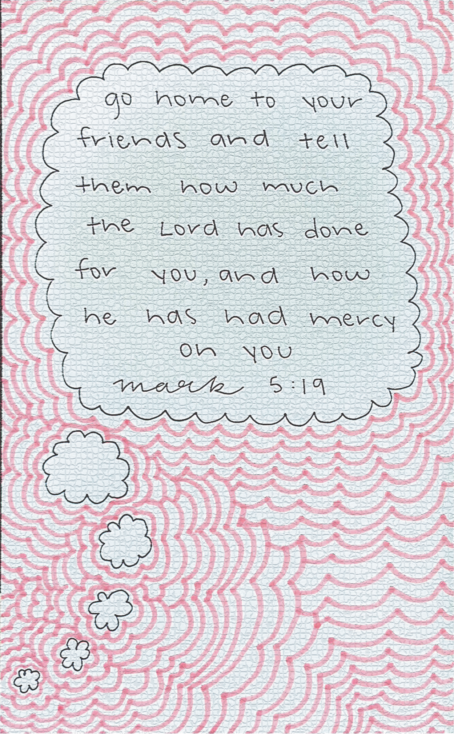

Day 1A: It Isn’t Supposed to be Easy

John 15:18-20 “If the world hates you, know that it has hated me before it hated you. ¹⁹ If you were of the world, the world would love you as its own; but because you are not of the world, but I chose you out of the world, therefore the world hates you. ²⁰ Remember the word that I said to you: ‘A servant is not greater than his master.’ If they persecuted me, they will also persecute you. If they kept my word, they will also keep yours.

When we think about being a Christian, we can often think it is just a name or a badge we wear. But it is so much more than that. It is an identity, a calling to be someone who represents the God of the universe. When Jesus came, He faces all sorts of adversity. He was perfect, but they came for Him and hated Him. This is important for us to consider. Often people think it is easy being a Christian. Sometimes it is presented as easier. It is presented as something that will make your life easier. Some go as far to say that you will have more friends, a bigger bank account and a healthier life. This may happen. Christianity does offer a community of believers. God also promises to provide for us as we are faithful in serving Him. We also know He is a healer and can keep us from any disease. However, this is not always the case, and it isn’t always the way we think it will be. The early disciples faced numerous setbacks, frustrations, wants and persecutions. But they knew they were set apart for a greater purpose.
I want you to think about the idea of being set apart. This means we are different from the common use. If you were going through a harvest of fruit and only wanted to pick the best fruits to give to someone special, you would set them aside as you sorted. They would have a different purpose than the rest. This is what God has done with us, that is if we have committed ourselves to Him.
If you consider these words Jesus said, you begin to see a picture painted of a world that comes against those committed to Jesus. He speaks of the world hating them and persecuting them. Considering these guys were all probably pretty young when they heard these words, I am sure it was a shocker to them. They probably thought following God would have a lot of perks in this world. They were out preaching peace and life and love. They were being kind and generous to people. They were offering them eternal life and the forgiveness of sins. Why would anyone be mad about that? This shows you the spiritual nature of this world. Satan has so blinded the hearts of people in this world that they come against even the most loving thing. They come against Jesus, which means they come against His followers.
I am saying all of this so you can understand the road is hard. The path is narrow you have been called to walk. While others swim downstream you have to swim upstream. It is a battle. You battle yourself and spiritual forces every day. Your friends and others around are one way but you are called to be different. They joke or don’t include you in things if you are different. They don’t like your moral positions. But ask yourself the question: Who are you here to please? Who matters? Who do you want to impress with your life? Is it God or men? This is a real issue facing most people you know. We want to fit in. There is nothing wrong with that desire. But we can’t let it be at the cost of our souls.
I want you to consider Jesus’s Words. He says if they hated Him, they would hate you. If they persecuted Him, they would persecute you. So, if you live a godly life, you can expect that there will be many that hate and persecute you. It will be at varying degrees depending on where you live in this world, but it will happen. But don’t let that dissuade you from living fully for God. Embrace it fully. Know that walking for God is difficult. You will stand out. You will be different. It isn’t meant to be easy. But we really never accomplish anything of worth without difficulty, do we? Jesus chose us out of this world. Why would we want to be like it or return into it? So, strive to be like Christ in all things, so you will reap the rewards in eternity.

What did you learn and how can you apply it?

Day 1B: You Are a Chosen People for Christ

1 Peter 2:9-12 But you are a chosen race, a royal priesthood, a holy nation, a people for his own possession, that you may proclaim the excellencies of him who called you out of darkness into his marvelous light. ¹⁰ Once you were not a people, but now you are God’s people; once you had not received mercy, but now you have received mercy. ¹¹ Beloved, I urge you as sojourners and exiles to abstain from the passions of the flesh, which wage war against your soul. ¹² Keep your conduct among the Gentiles honorable, so that when they speak against you as evildoers, they may see your good deeds and glorify God on the day of visitation.

I am sure by now we have had a couple delays and are running behind; such is the nature of big trips like this. This is a good time to focus on some powerful words out of God’s Word. In this text Peter is reminding God’s people who they really are and what their purpose in this life is.
He begins by telling them who they are. He lists four things. He calls them a chosen race, a royal priesthood, a holy nation, and a people for his own possession. If you have trusted in Jesus as your Savior AND submitted to Him in repentance as your Lord, he is talking about you. He is talking about you. You are a chosen person. You are a part of a royal kingly priesthood. You are part of a holy nation. You are a person that belongs to God. These are fantastic realities for us, and we should consider this strongly.
God is trying to tell us that we are of great value to Him. This is also written so you will know who you are and who you represent. Sometimes we need to be reminded of these things. We need to be reminded who we are. Yes, you at 12 to 18 or if you are a college student or an older adult these things are true of you. It doesn’t matter what others say about you. What has God said about you? What God has said about you is who you are. When you fail, you are still who God says you are. This is very encouraging and powerful if you will hear it and embrace it. These truths free you up to serve Him faithfully and live your life in abundance for Him.
There is another aspect of who we are that he mentions. He says we are people who once didn’t receive mercy, but now we have. God has had mercy on us. Through the death of Jesus God has poured out His mercy in our lives making all this possible.
He doesn’t just tell us who we are, he also tells us our purpose. He says, “that you may proclaim the excellencies of him who called you out of darkness into his marvelous light.” What a purpose. To proclaim the excellencies of God! He called us out of darkness and brought us into light. We need to tell people about that. We also need to realize how powerful it is for God to do this for us. If we do not see God as excellent, we do not see Him. If we do not see His light as marvelous then we do not understand it.
He tells us more. He urges them to live godly and set apart lives. He essentially is telling them to keep themselves set apart for God. We are not to live our lives serving our flesh, rather we are to deny our sinful fleshly desires and live in a godly manner. Then notice the purpose. We want others to see our lives and glorify God. We do not want people to think less of God because of how we live our lives. We want them to think God is holy and set apart just like His servants.
How is your conduct? Peter says let it be honorable. Is your conduct honorable before others? How would others describe you? As a godly person or just like them. How is your speech? How are your actions? Are they saying something different than what you claim to be? Let these words build you up in Christ.

What did you learn and how can you apply it?

Day 2 Memory Verse
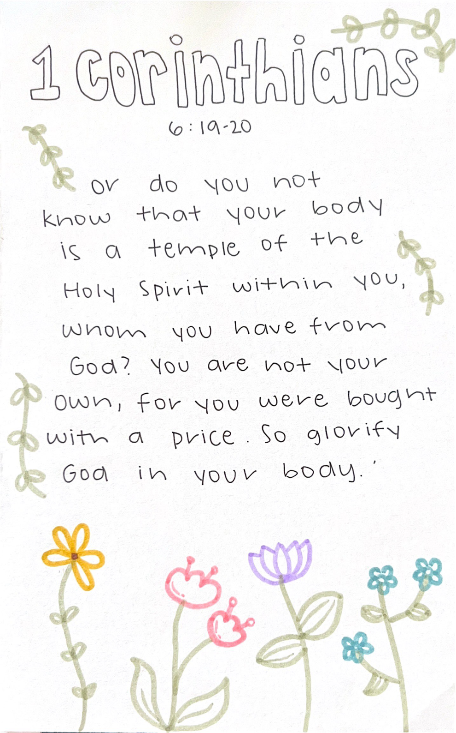

Day 2: You Are Not Your Own

1 Corinthians 6:19-20 Or do you not know that your body is a temple of the Holy Spirit within you, whom you have from God? You are not your own, ²⁰ for you were bought with a price. So glorify God in your body.

There may be no more practically convicting verses in all the Bible than these. We are born into this world with the sense of thinking that our body is our own. We can decide what is good for it and what isn’t. We spend our lives doing what we want. Now, for some of us this isn’t true. Our parents are often putting rules on us regarding what we do and don’t do. But here God reminds us of the reality of existence. It is always good when God reminds us of important things.
Here He says that our body is a temple for the Holy Spirit within us. This does imply that you know God and have the indwelling Spirit of God. A temple is a dwelling place. Paul is asking them if they know this. This is actually the 8th of ten times he will ask this question in this letter to the Corinthians. He asks, “Do you not know”? I don’t think he is being sarcastic. I do think he is pointing out to them their ignorance, however. They should know, but they weren’t living in a way that proved it. One scholar write this, “The general lesson is clear: You are God’s consecrated shrine, through the Spirit’s indwelling, and you are therefore relatively holy;… The body has been sanctified; let it fulfill its proper end, that of bringing glory to God whose temple it is.”
In Romans 8:9, another book God instructed Paul to write he said this, “You, however, are not in the flesh but in the Spirit, if in fact the Spirit of God dwells in you. Anyone who does not have the Spirit of Christ does not belong to Him.” This hits us hard, doesn’t it? He says we are of the Spirit only IF the Spirit of God dwells in us.
We are reminded in verse 19 that this has come from God. It is a gift from Him. He formed us from the dust of the earth in the beginning, didn’t He? Then it says that He breathed the breath of life into us, and we became living beings. Once a person comes to know Jesus, they are then given His spirit. Not only do we have our own, but we are given His. We can walk around daily with the Spirit of God dwelling within our person. We are His dwelling place. So, then we learn that this means we are not our own, we are His.
Paul explains why this is so certain. He tells us it is because we have been bought. We have been purchased. The price was extravagant. Have you ever spent a lot of money on something? When you do, don’t you take good care and concern over it? This is what Paul is saying here. The price for us was extremely high. We were not bought with things that perish, rather we were bought at a real cost. The cost was the precious blood of Jesus. Jesus paid this price on the cross as His blood ran from His body to take away the wrath God had toward us. This was the payment for what we had done wrong.
Slavery was common in those days. Paul is borrowing that image and then multiplying it. This imagery is to remind us of the fact that we are bought with a price and now belong to another master. The world isn’t our master. The devil isn’t our master. We aren’t our own masters. God alone is our owner. He is a good and gracious owner. He frees us from the slavery to other masters that don’t love and care for us. He comes along and offers love and freedom and life.
Please remember these things daily. Let them guide you in all you do and speak. Remember you do not have freedom to do as you want. You must ask God first. You must ask the Holy Spirit if He is good with such things. Give over the kingship of your life to the God who made you and the bought you at such a high cost. Just to bring it to a practical point, Paul gives us some wisdom in Romans 12:1 when he says, “I appeal to you therefore, brothers, by the mercies of God, to present your bodies as a living sacrifice, holy and acceptable to God, which is your spiritual worship.” Lay down your life for him. Honor Christ in your body in all you do. Peter would remind us to live this way in 1 Peter 2:16 saying, “Live as people who are free, not using your freedom as a cover-up for evil, but living as servant of God.”
I know this may seem like a lot. It may seem difficult. But it is the best possible way for us. To be fully sold out to God in all ways is the highest form of living. Don’t settle for less.

What did you learn and how can you apply it?

Breakout Session 1 – Morning

Genesis 1:27 So God created man in his own image, in the image of God he created him; male and female he created them.

Daniel 12:3 And those who are wise shall shine like the brightness of the sky above; and those who turn many to righteousness, like the stars forever and ever.

Biblical Example: Barnabas

Notes:

Main Session 1 Notes

Breakout Session 2 – Evening

Philippians 2:14-16 ¹⁴ Do all things without grumbling or disputing, ¹⁵ that you may be blameless and innocent, children of God without blemish in the midst of a crooked and twisted generation, among whom you shine as lights in the world, ¹⁶ holding fast to the word of life, so that in the day of Christ I may be proud that I did not run in vain or labor in vain

Biblical Example: Mary

Notes:

Day 3 Memory Verse
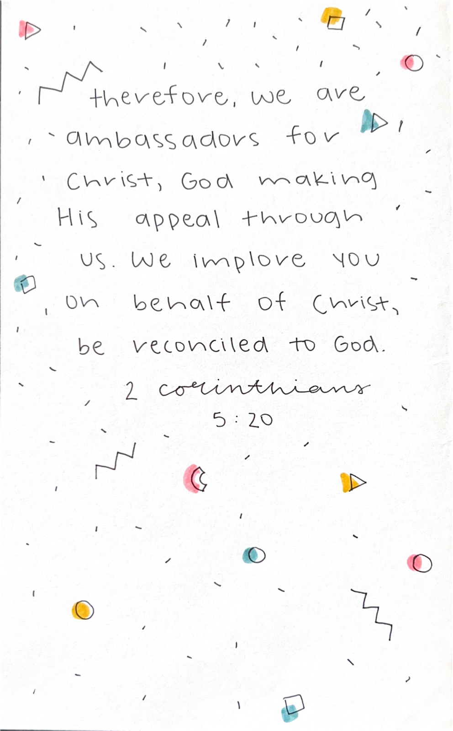

Day 3: Set Apart as Holy to God

2 Timothy 2:19-20 But God’s firm foundation stands, bearing this seal: “The Lord knows those who are his,” and, “Let everyone who names the name of the Lord depart from iniquity.” ²⁰ Now in a great house there are not only vessels of gold and silver but also of wood and clay, some for honorable use, some for dishonorable. ²¹ Therefore, if anyone cleanses himself from what is dishonorable, he will be a vessel for honorable use, set apart as holy, useful to the master of the house, ready for every good work.

Growing up in the 21st century, it is almost impossible to not encounter some type of technology on a daily basis. While people in Biblical times, or even our parents and grandparents, did not face this modern upbringing, ‘Generation Z’ is constantly faced with the temptation of the internet. Don’t get me wrong, the proper use of technology is a very helpful thing and can often be used as a tool for ministry. However, as with most things, we often abuse the limitations of this advancement in our society. If I had to take a guess, I’d say you’re like me. You probably have the Bible app downloaded on your phone. You may set a memory verse as your screen saver. You may even text, call, or use social media to invite others to church. Unfortunately, these are not the only things we use our phones for. Think about it like this: we each have our own personal cell phone; and chances are, you are the only one who has access to your screentime or search history. The same screen that can display God’s Word can also display things that will stunt your Christian growth. Your phone, or the internet in general, can be used for both honorable use and dishonorable use.
Human beings are fairly similar to this. Some blindly work for the enemy as a dishonorable vessel. Incredibly, that was the reality for all of us, even Christians, before we surrendered our lives to God. By the Lord’s grace and mercy, we can now be used as tools of honorable use to expand the Kingdom. Is it not crazy that God uses broken people like us to accomplish His perfect will? After all, He is God. He could easily find a way using only Himself to reach those who will become His children. For some reason, He uses us, motivated by the Holy Spirit of course, to accomplish His purpose and advance the gospel.
We see Paul state in Romans 12 that we are called to offer up our lives as a human sacrifice. However, a sacrifice has no middle ground or grey area. You are either for Christ or against Him. As Christ-followers, we do not have the freedom to live for our own fleshly desires and run to the Father only when we need Him for a favor. Unfortunately, this is how much for the world views a relationship with God. They view Him as a magic genie who grants our wishes through our occasional prayers of petition, or even as a ‘Get Out of Hell Free Card’. A true relationship with the Lord does not work in this way; it is about offering up our lives as a human sacrifice to be set apart from the world. Is Jesus only your Savior?; or is He also the Lord of your life?
Peoples’ natural default is to fit in. We all have fallen victim to it at some point or another. This is often because of how much we live in the moment. We want to do the things that will offer temporary satisfaction, temporary popularity, or temporary possessions. That’s the thing though; it’s all just temporary. God is forever. Take it from me, who has only been out of high school for a few years now: in about five years, nobody is going to remember the clothes you wore, the car you drove, or the friend-group that you were in. However, active evangelism has eternal rewards. We are called to be set apart from this world. We are called to be the vessels of gold and silver, not of wood and clay. Do not waste your life living for yourself or the world. Submit to the perfect will of God and allow Him to use you as a tool to advance the Kingdom.

What did you learn and how do you apply it?

Breakout Session 3 – Morning

1 Corinthians 5:20-21 Therefore, we are ambassadors for Christ, God making his appeal through us. We implore you on behalf of Christ, be reconciled to God. ²¹ For our sake he made him to be sin who knew no sin, so that in him we might become the righteousness of God.

Biblical Example: Paul

Notes:

Main Session 2 Notes

Breakout Session 4 – Evening

1 Corinthians 9:22-27 To the weak I became weak, that I might win the weak. I have become all things to all people, that by all means I might save some. ²³ I do it all for the sake of the gospel, that I may share with them in its blessings. ²⁴ Do you not know that in a race all the runners run, but only one receives the prize? So run that you may obtain it. ²⁵ Every athlete exercises self-control in all things. They do it to receive a perishable wreath, but we animperishable. ²⁶ So I do not run aimlessly; I do not box as one beating the air. ²⁷ But I discipline my body and keep it under control, lest after preaching to others I myself should be disqualified.

Biblical Example: John the Baptist

Notes:

Day 4 Memory Verse

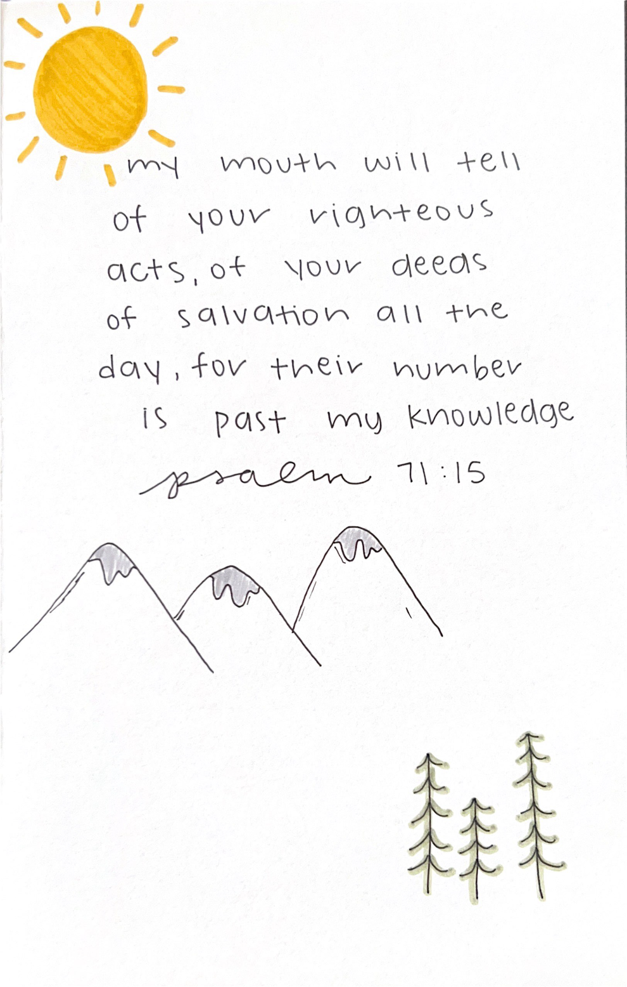

Day 4: Proclaim it All

Matthew 10:27 What I tell you in the dark, say in the light, and what you hear whispered, proclaim on the housetops.

People tend to not like to be around those who are conceited, but sometimes it’s hard to not share in your excitement about good news. Growing up, I would always get so embarrassed when my parents would brag on me for even my smallest accomplishments, but I realize now they were just very proud. When I finally got my 89’ Chevy Cheyenne pickup truck in high school, everybody in my class knew I had a powerful wench on the front so that Jonah Kyle could come to the rescue and save the day if any of my friends ever got stuck. When I started dating my now fiancé, I could not wait to blast it on social media to proclaim to the world that I pulled such a beautiful girl.

The truth is, the good that happens in our lives is often easy to work into a conversation. If this statement is true, why are we so hesitant to share the best news of all? Is the good news of the gospel not more important or exciting than a truck or a girlfriend? We as humans can often become near-sited and closeminded with what really matters. The busyness of life blurs out what the big picture is supposed to be. We get caught in our daily routines: wake up, go to school, go to practice, hang out with our friends, do some homework, eat a meal, go to sleep. Who has the time or energy for anything outside of that?

In Matthew 13, the Kingdom of Heaven is compared to a hidden treasure found in a field. The man sells all he owns to purchase the field in order to gain the treasure worth more than everything combined. God sometimes blesses us with things to brag on, but there is no treasure comparable to eternal life. The sovereign God of the universe, outside of space and time, not only died a brutal death that you and I deserved, but He also wants a personal relationship with you. That sounds like something I want to tell others about.

The most hateful thing you can do as a Christ-follower is not missing a church service or forgetting to read your Bible one day. The most hateful thing we can do as Christians is not tell others about Christ. Look at it this way: If God gave me a vision in the middle of the night and told me the cure for cancer, I would not wait until the following morning to tell others, and I would not just tell a few people I know. I would immediately get on the phone with every news station I could call and drive to every university and hospital I could get to and share that information. Think about how many lives could be saved with that good news. Here’s the thing: the cure for cancer could prolong somebody’s life for 20, 30, 40 years or so. The gospel grants a life with God the Creator forever. You would obviously tell somebody if they were unknowingly on fire, yet we walk by, sit by, and conversate with people every day who are lost and on a wide and devasting road to an eternal death in separation from God.

The world today will tell you to keep your beliefs to yourself. “We would not want to offend anybody.” Does that statement sound familiar? While it is important to be tactful with our approach, especially since the gospel is offensive enough, it is our job as believers to tell people what God has done for us! What do you have to lose? Somebody may think you’re weird or a little pushy; they may call you a Jesus-freak; they may even stop inviting you to come around. What do we have to gain? That person just may humble themselves and surrender their life to Christ and join the team to help reach even more people. On a balance scale, the reward greatly outweighs the risk.

We see countless times throughout the scriptures, most famously in the Great Commission, to go and tell. Jesus is no longer physically here. We are the only physical representation of God here on Earth, and that holds a lot of weight. You may have several Christian friends, but there is a good chance you may be the only example of who God is in somebody’s life. Do not let those opportunities slip away. See everywhere as a mission field. Realize that God was gracious enough to save you, and want others to experience that same blessing.

What did you learn and how do you apply it?

Breakout Session 5 – Morning

Acts 9:15-16 But the Lord said to him, “Go, for he is a chosen instrument of mine to carry my name before the Gentiles and kings and the children of Israel. ¹⁶ For I will show him how much he must suffer for the sake of my name.”

Biblical Example: All of the Disciples

Notes:

Main Session 3 Notes

Breakout Session 6 – Evening

2 Timothy 4:1-2 I charge you in the presence of God and of Christ Jesus, who is to judge the living and the dead, and by his appearing and his kingdom: ² preach the word; be ready in season and out of season; reprove, rebuke, and exhort, with complete patience and teaching.

1 Peter 3:15 but in your hearts honor Christ the Lord as holy, always being prepared to make a defense to anyone who asks you for a reason for the hope that is in you; yet do it with gentleness and respect,

Biblical Example: Paul

Notes:

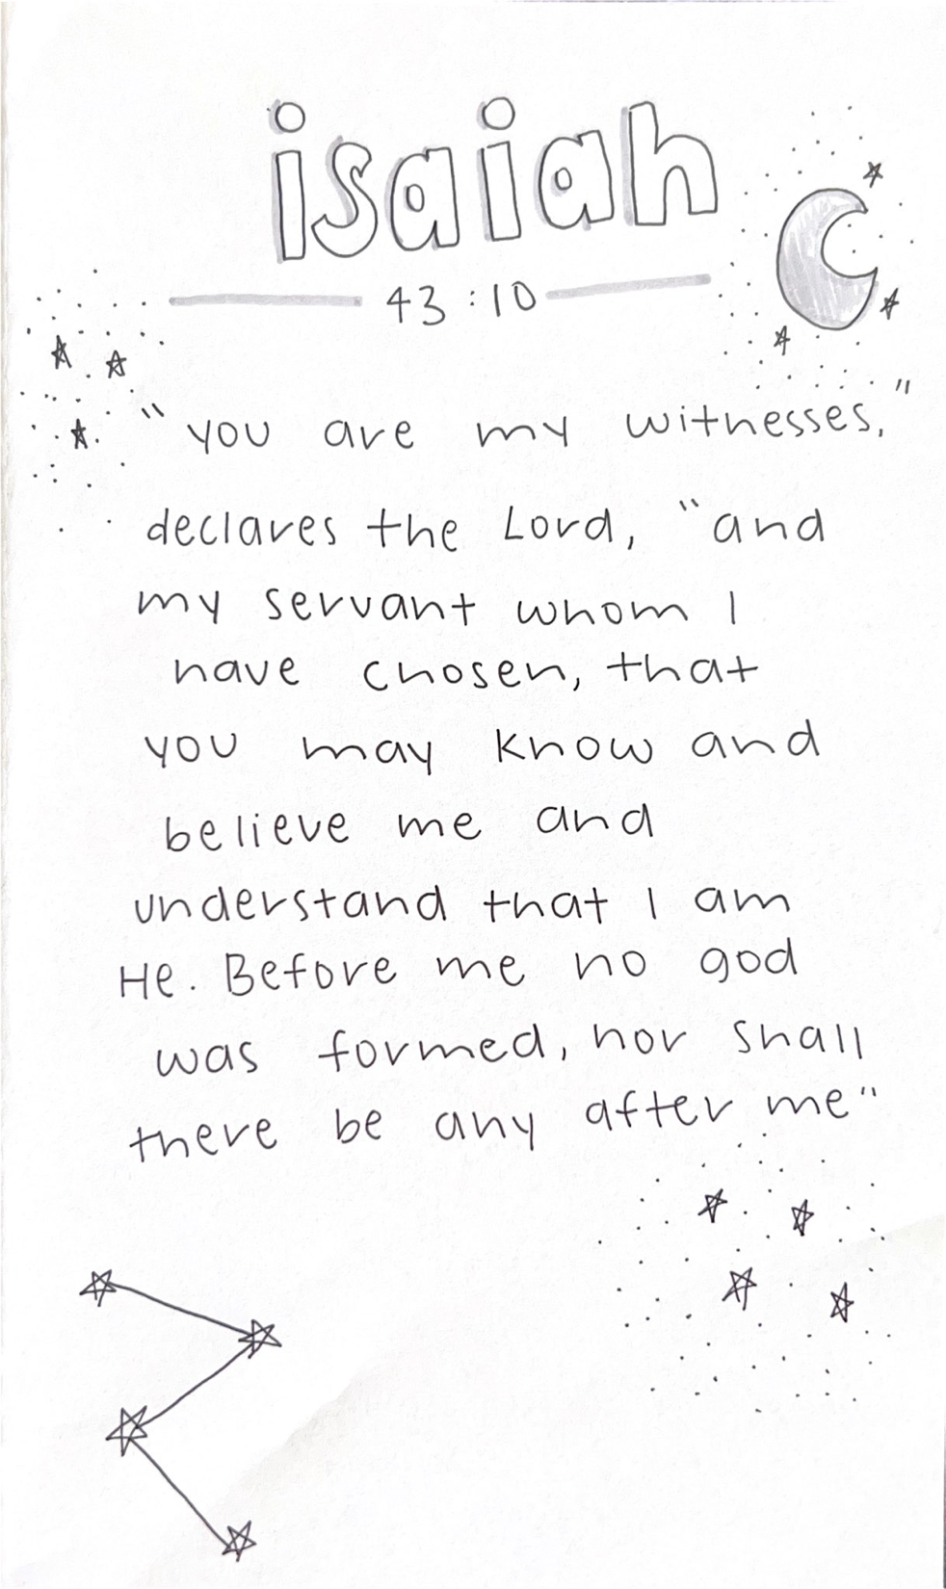
Day 5 Memory Verse

Day 5A: Remind Others of God’s Deeds

Psalm 71:15-16 My mouth will tell of your righteous acts, of your deeds of salvation all the day, for their number is past my knowledge. ¹⁶ With the mighty deeds of the Lord God I will come; I will remind them of your righteousness, yours alone.

This is a beautiful Psalm that reminds us of what God has done. Again, we are reminded of our responsibility to tell of these things. He begins with his mouth! The focus with his mouth is on what God has already done. He speaks of God’s salvation, and we see that it is inseparable from righteousness. This means to be righteous you must be saved and if you have experienced God’s salvation you are considered righteous. This is such good news. Earlier in this Psalm in verse 8 the writers says, “My mouth is filled with your praise, and with your glory all the day.” Then we can go look at Psalm 35:28 and see this, “Then my tongue shall tell of your righteousness and your praise all the day long.”
We learn here the importance of using our words to declare the goodness and greatness of God. God created our mouth for such things. Our mouth is not to be used to put others down or do as we want. It is created and fashioned by God to declare to the world around us of all He has done. He has done great things. He has brought about salvation through His Son. We could do this all day long and never run out of good things to say about Him. He says as much when he says their number is past his knowledge. His merciful acts toward sinners are innumerable. This reminds me of what John said about Jesus at the end of his gospel book. He said, “Now there are also many other things that Jesus did. Were every one of them to be written, I suppose that the world itself could not contain the books that would be written.” Jesus had done so much that there aren’t enough books for it. Do you find the things of God boring? He isn’t the problem. The problem is us and our lack of wisdom and taste for the things of God.
God is always working. Even when we are unable to see it. God must open our eyes so we can see all His ways. Often, we are so dull of hearing and seeing that we do not recognize it. But what the psalmist says in Psalm 40:5 must be true, “You have multiplied, O LORD my God, your wondrous deeds and your thoughts toward us; none can compare with you! I will proclaim and tell of them, yet they are more than can be told.”
If we continue with this song of Psalm 71, we see the singer singing that he will come with the righteous deeds and remind others of them. He is saying he will bring them to the front. He will remind people that it is God alone that has done these things. They cannot be attributed to ourselves or mighty warriors or kings. They are His alone and only He deserves the praise. So as you consider these verses consider your role in being a person of praise toward God. Consider your role as one who tells others of what God has done.
How often do you praise God. If you are like most people I know, it is very seldom. You like music but you don’t spend much time in praise. This must be change. The bible tells us that God inhabits the praises of His people. The presence of God literally dwells in your true and authentic praise. That is a powerful event! You must seek this in your life. We must long for the presence of God every single day. People that sing to the Lord are powerful witnesses of His presence. I want you to be that. I think you do also.

What did you learn and how do you apply it?

Day 5B: He is the Only God and Savior

Isaiah 43:10-12 “You are my witnesses,” declares the Lord, “and my servant whom I have chosen, that you may know and believe me and understand that I am he. Before me no god was formed, nor shall there be any after me. ¹¹ I, I am the Lord, and besides me there is no savior. ¹² I declared and saved and proclaimed, when there was no strange god among you; and you are my witnesses,” declares the Lord, “and I am God.

If you have made it to this last devotion, I am proud of you. If you did, I want you to come to me and tell me your favorite ice cream. I’ll forever think you are amazing!
The book of Isaiah is written about 750 years before the birth of Jesus. Isaiah was a prophet in the nation of Israel. This means that He spoke the words of God to the people. During this time Isaiah is warning the nation about their sins and reminding them of who He is and who they are to be. I understand that we are not of the nation of Israel. But we are God’s people. So, there is much for us to learn from how God spoke to them because it applies to us in a very similar way in our day.
He has said a lot so far in Isaiah. This passage comes after 42 other chapters. Here we see God reminding the people that they are His witnesses. He has just spent some time declaring who He is and what He has done. He wants them to know this and make sure others know it. He is saying essentially, you guys know this because you have seen it. You have seen what I have done and how I have treated you.
It is a beautiful reminder of how God works in our lives. He calls us and leads us and equips and then He uses us. I love how we are reminded that we are servants that are chosen by Him. This is so encouraging to me. God knows me enough to choose me! This makes me want to serve Him even more.
Notice what He wants them to do. One, He wants them to believe and understand. He wants them to understand that He is who He says He is. This is so important. We must take God at His Word. He says He is the only God. There is no other. He was first and He is last. No God before Him or after Him. This is a powerful statement during its day and continues to resonate today. In those days there were so many nations around Israel and people within Israel worshipping other gods. They claimed these gods were real. God says they are not. He is alone. This is very similar to the day in which we live. So many people think they can have their own truth even if it contradicts other “truths”. Today it is seen as intolerant to tell people they are wrong in their beliefs. The reality is that they are. There is one God and He has one Son, Jesus. We must be witnesses of this to others. It is not kind or loving to hide this truth from others. They may be against it, but it is good for them to know who God is, what He has done and what He expects. Do not shy away from this. Do not be a coward regarding your faith. Confess Him before others.
In verse 11 He tells us why this is so important. He says only He is Savior. There are no other gods that even claim this. The demonic spirits behind these belief systems claim a lot of things. But none of them claim to be Saviors. Only Jesus died in our place. Has another religion claimed such a thing? They haven’t because they can’t. Even in their lies they can’t claim to be a Savior.
He says here that He has declared and saved and that He alone is God. Do you meditate on this reality in your life? If it is true, what does this demand of you? If these things are true, how should you respond? I think this frees us up to live in boldness with no worry of the consequences. If God is for us who can be against us? This is what Paul asks in Romans. He says that because it is true. Only the God of the Bible is God. Only Jesus is Savior. We must be His witnesses of this truth. Witnesses share their testimony concerning what they know. Don’t hide from this. Spend your life being a witness of the good He has done for you!

What did you learn and how can you apply it?





