priorities.
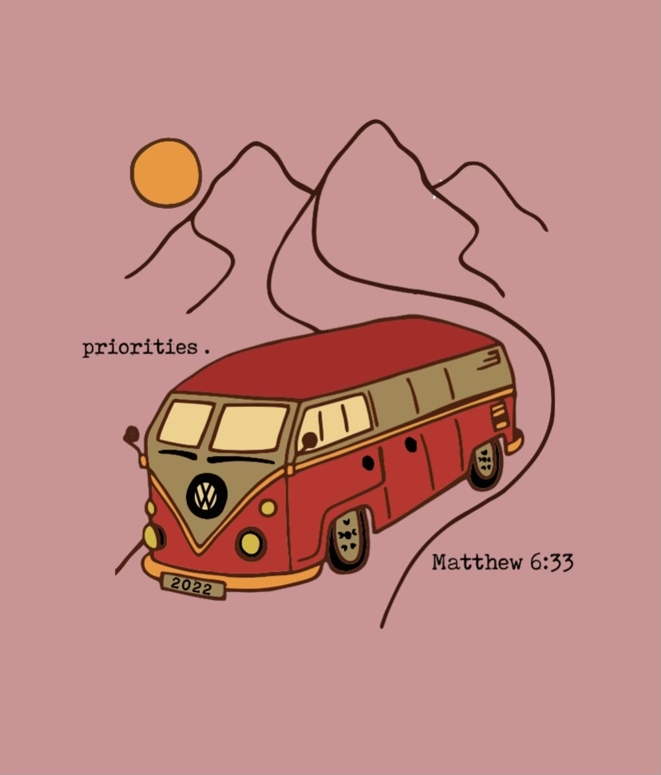

Finding Time for God in a Distraction Filled Life.

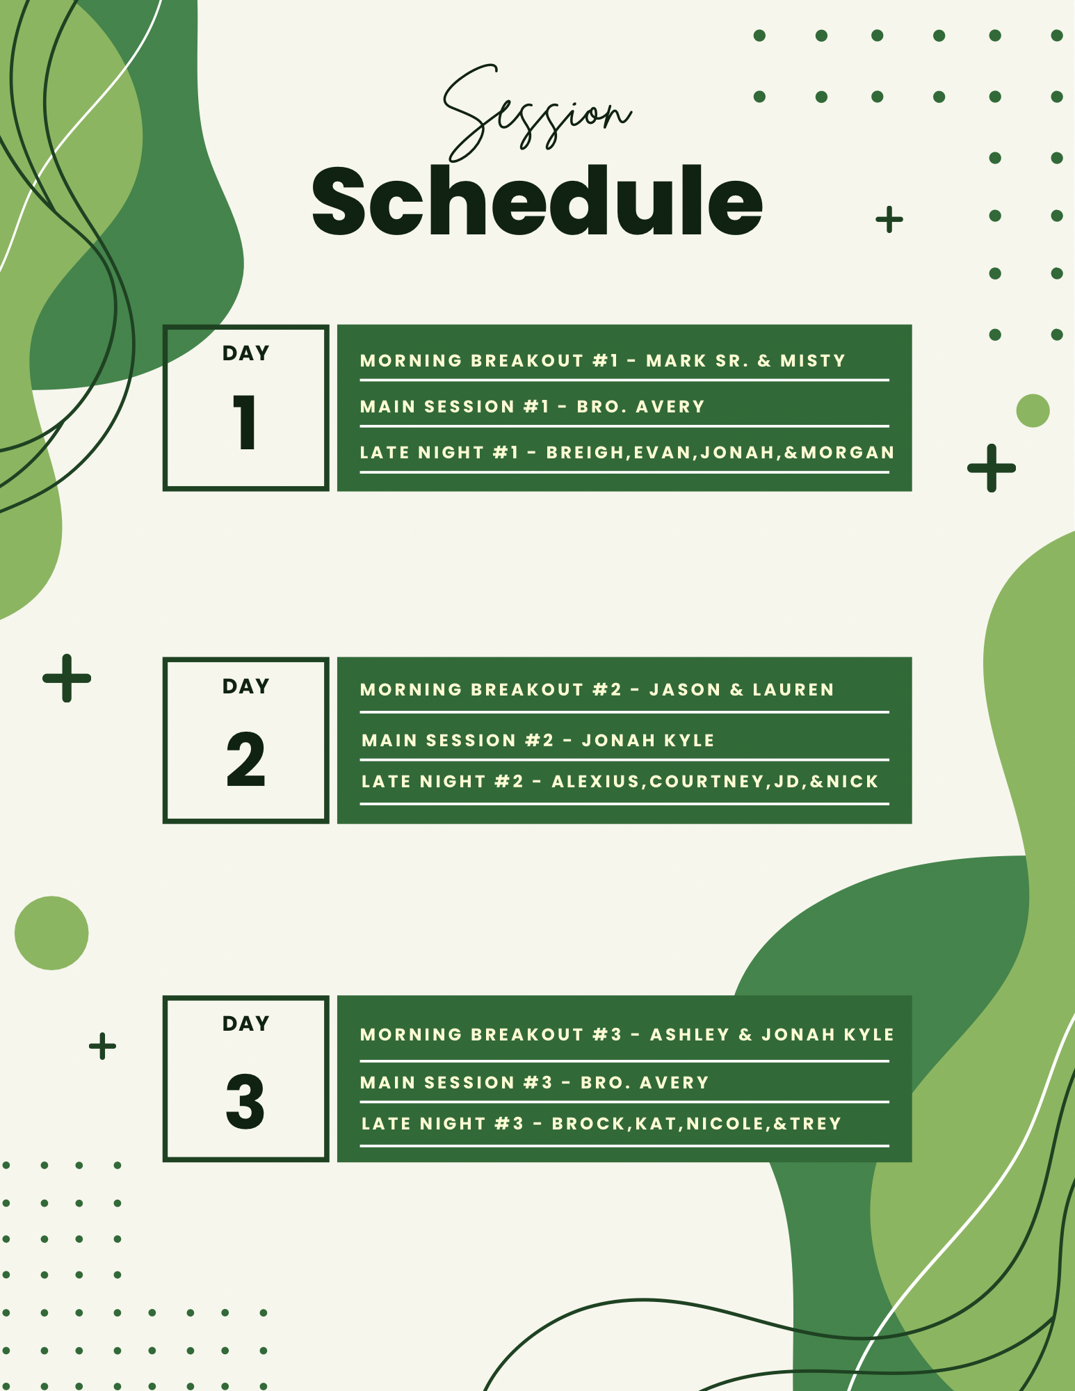

DNow Memory Verse
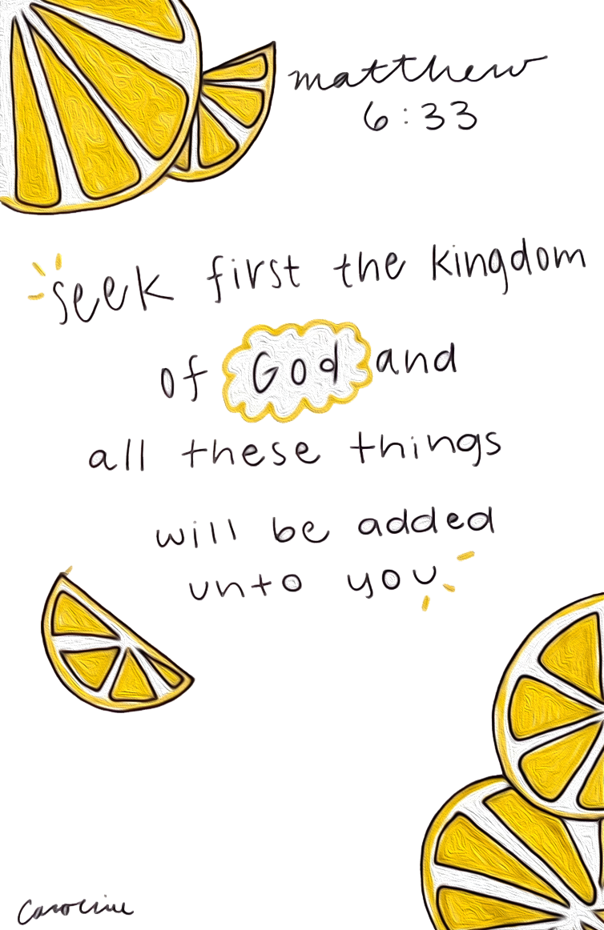

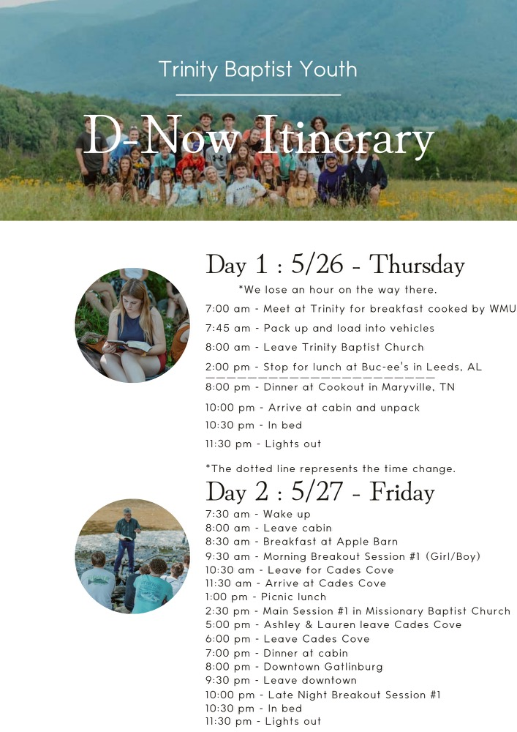

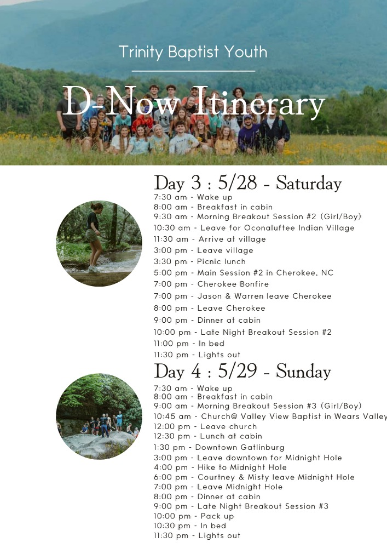

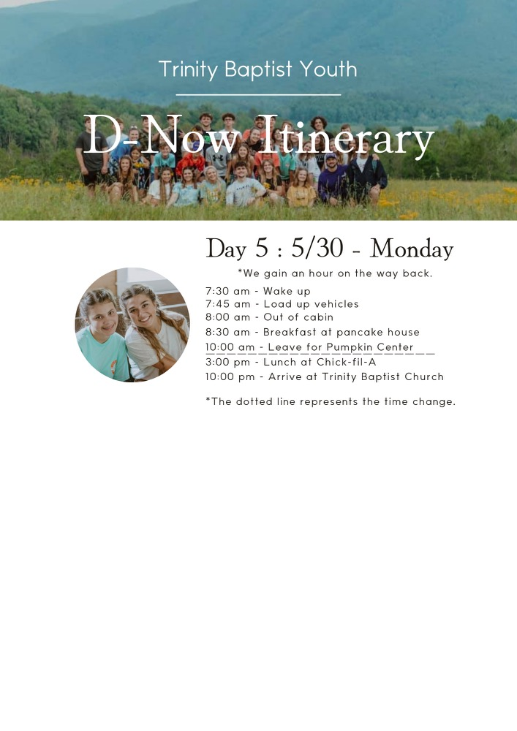



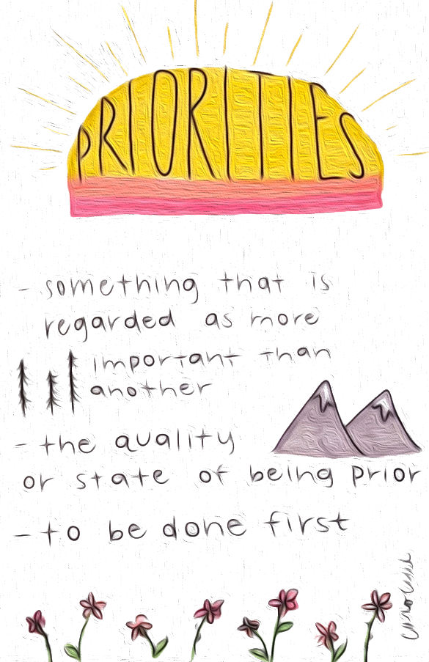

Notes…

Day 1 Memory Verse

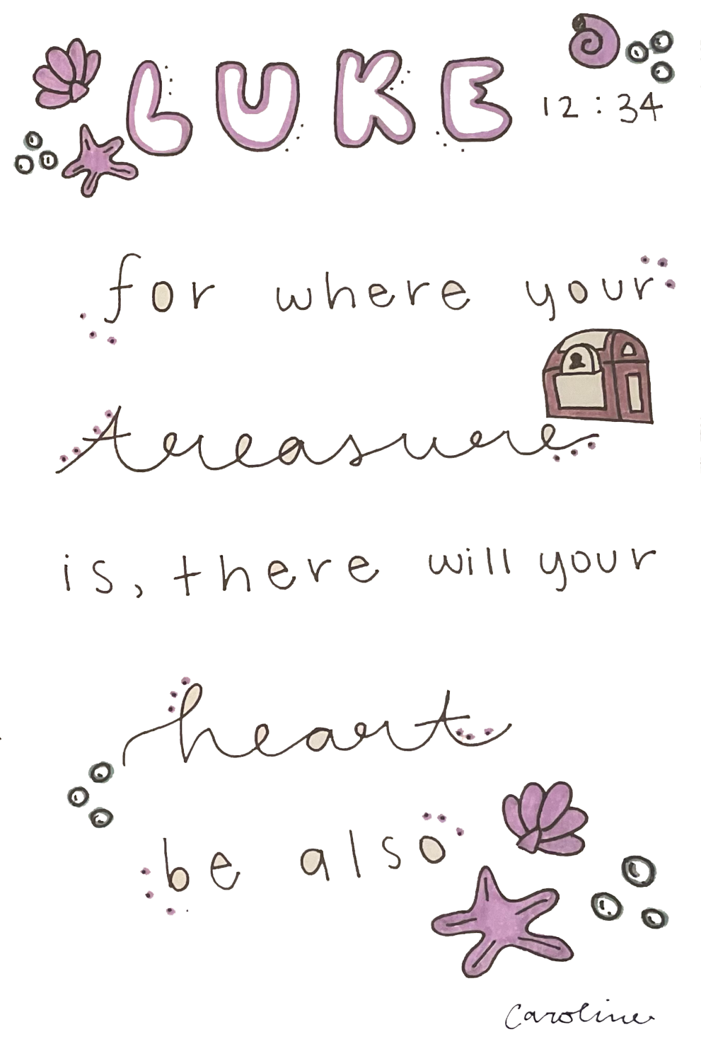

Day 1A: The Priority of the Gospel

1 Corinthians 15:1-6 Now I would remind you, brothers, of the gospel I preached to you, which you received, in which you stand, ² and by which you are being saved, if you hold fast to the word I preached to you—unless you believed in vain. ³ For I delivered to you as of first importance what I also received: that Christ died for our sins in accordance with the Scriptures, ⁴ that he was buried, that he was raised on the third day in accordance with the Scriptures, ⁵ and that he appeared to Cephas, then to the twelve. ⁶ Then he appeared to more than five hundred brothers at one time, most of whom are still alive, though some have fallen asleep.

When we think about priorities in the Christian life, there is none greater than the gospel. This “good news” is what our entire life and faith Is based on if you have come to Christ. Today you should be embarking on our long 10+hr drive to Tennessee. It is a great time to consider the priority of the gospel in your lives, as well as have a lot of fun with whoever you are sitting by. In this passage about the gospel, the writer is Paul the apostle. He is being led by God to write some things to a church in the city of Corinth. The people there were very important to him. He wanted to make sure they fully understood the good news about Jesus.
The reason this good news is so important is because without it no man will find peace with God when they die. He writes here a summary statement about the gospel. He says that Jesus died for their sins, was buried and then rose from the grave. This is an amazing and supernatural event. It might be something one would read and have a hard time believing. But that would be a mistake, wouldn’t it? Paul makes sure they understand he isn’t just saying things. He says there is proof. He offers up two main proofs, and they are truly worth our time to consider.
The first is that he says all these things happened according to Scripture. So, he is saying all these things that occurred were written down hundreds of years before they happened. If you were to take the time to read through what we call the Old Testament part of the Bible, you would come across hundreds of times where the life, death and resurrection of Jesus were spoken of prior to it happening. We call this prophecy. There are hundreds of them, with some dating back thousands of years. The second proof he offers is that there were eyewitnesses that saw Jesus alive after He was killed. There were even hundreds that saw him at the same time. That is more than enough to at least make us consider Jesus in our lives.
So, what are you to do with this thing we call the gospel? First you need to understand it. And if you think you do, you should seek to understand it even better. The gospel teaches us that we are people that have sin in our lives and the potential for so much more. Remember Eve only sinned that one time and it still led to things far worse than she ever imagined. But God being rich in mercy toward us sent His Son to live a perfect life in our place, then to die on a cross in our place and then rise from the dead taking on the punishment we deserve. We call it gospel or good news because the results mean we can have our sins forgiven and be granted eternal life in heaven with God.
But this beautiful event that God has done only applies to those who follow Christ. We must respond to what God has done. We must first believe these things and then turn from our sin and unbelief toward God. We call this faith and repentance. If this has never happened in your heart and mind, pray that God will open the eyes of your heart so you may see and understand. And then respond to this good news. If you still have questions, ask someone you think knows. If it has happened, pray for a greater understanding and for help living it out more faithfully so you can be a person that reflects the gospel to the world around you. Enjoy your trip!

What did you learn and how can you apply it?

Day 1B: Prioritizing the Right Things

Haggai 1.9-11 ⁷ “Thus says the Lord of hosts: Consider your ways. ⁸ Go up to the hills and bring wood and build the house, that I may take pleasure in it and that I may be glorified, says the Lord. ⁹ You looked for much, and behold, it came to little. And when you brought it home, I blew it away. Why? declares the Lord of hosts. Because of my house that lies in ruins, while each of you busies himself with his own house. ¹⁰ Therefore the heavens above you have withheld the dew, and the earth has withheld its produce. ¹¹ And I have called for a drought on the land and the hills, on the grain, the new wine, the oil, on what the ground brings forth, on man and beast, and on all their labors.”

Hopefully by now we have made some good time and haven’t had to stop 10 times for bathroom breaks! Let’s take a little more time out of the monotony of driving to consider more about our priorities. The issue isn’t that we do not have priorities, this issue is that they are often out of order. We focus on things that are just not that important over and above the essential things. We are like farmers that try to plant seeds before they even till up the ground. We are like Tik Tok creators trying to create videos before we get a camera. We are like drivers that neglected changing the oil or putting in the proper amount of air into the tires. When things are out of order, it creates chaos in our lives. In the text above, the people of Israel had begun to put the wrong things first. They worried more about their own homes and their own stuff than the place where people gathered to meet with God. It showed what was important to them. They busied themselves with their own houses. Now, you may say, I do not know how this applies to me at all. Well, I am glad you asked!
The Bible teaches us that we are a temple for the Holy Spirit. We know that our outside body is not all there is. We know that within each of us is our soul. We spend a lot of time in our lives attending to other things that are just not that important. We wake up and often find ourselves on our phones before we even leave the bed. Then, maybe we text a couple people or get on social media. We all know that we do this too much. If you are into sports, you read a lot of sports articles and if you are into tik tok you scroll mindlessly through videos. Before we know it, so much of our day is lost and we are behind. We quickly get dressed and off to school or off to work we go with no mind paid toward God. For some of us we repeat this throughout the day at various times all the way until we go to bed.
Then, there are the good things we take time on. We may workout or study or clean around our homes or even cook. We may be on a team and have to practice. All these things are good things. They are good just like the people of Israel’s houses were good. God did not speak judgment against them for having houses and being concerned for them. However, He spoke against them prioritizing their own things before God things. If we apply this passage in our day, we must see the connection. How often are we prioritizing building something else in our life and not building up God in our life? If our bodies are the temple for the Spirit of God, how well are we at attending to that temple in spiritual ways? How often are we in God’s Word, Prayer and Praise? How concerned are we for spiritual things?
The results of neglecting the spiritual things in our lives can be catastrophic if they go on long enough and are severe enough. For the people in Israel God brought a time of drought to them. He withheld blessings from them. This is a serious matter. No one that claims to be a Christian wants to have times of spiritual drought. The good news is that it is easy to step back into the blessings of grace that flow from God. But we must put ourselves in position to receive these blessings. Ignoring God and spiritual disciplines in our lives will not do it.
Paul the apostle said that he trained his body into submission. In 1 Corinthians 9:27 he says, “But I discipline my body and keep it under control.” This is what it will take for all of us. We must put ourselves on schedules and make plans to walk with God. We must find ways to create accountability in our lives. None of these things are that easy in the culture in which we live. We are too busy. But this is not a good thing. At the beginning of our passage today it says, “Thus says the Lord of hosts: Consider your ways.” Consider means to think on and reflect on something. So, commit yourselves to being people that love God and show it by the effort you put in to prioritize His things in your lives.

What did you learn and how can you apply it?

Day 2 Memory Verse
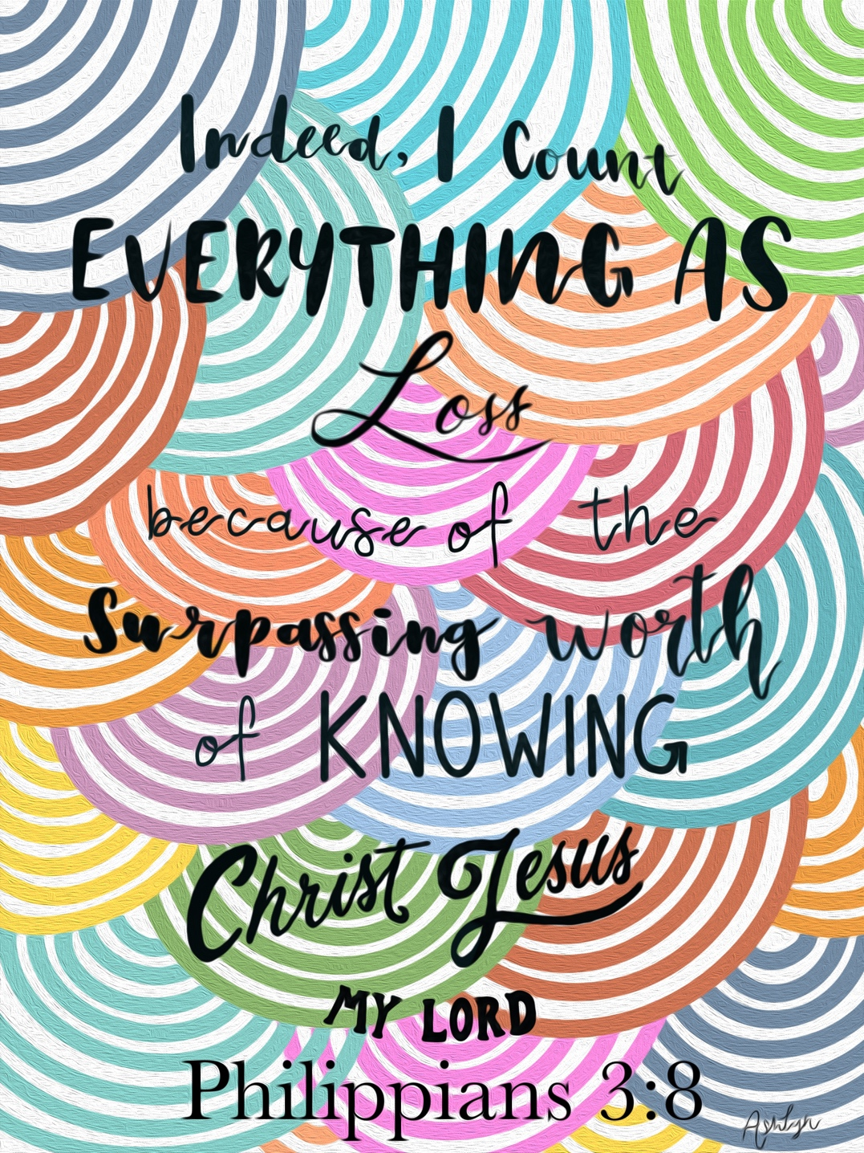

Day 2: Prioritizing the Presence of God

Psalm 16:8-11 I have set the Lord always before me; because he is at my right hand, I shall not be shaken. ⁹ Therefore my heart is glad, and my whole being rejoices; my flesh also dwells secure. ¹⁰ For you will not abandon my soul to Sheol, or let your holy one see corruption. ¹¹ You make known to me the path of life; in your presence there is fullness of joy; at your right hand are pleasures forevermore.

Ok. So, it is day two. You may be worn out and a little cranky from the drive up yesterday. But today is filled with a lot of fun things. I was thinking about how our theme is “Priorities” for this weekend. Then I looked at our schedule and it is filled with a lot of stuff. This “stuff” is good stuff, but it will take up a good portion of our day. I thought how silly it would be for us to come up here and have a theme of “Priorities” and then not prioritize our time of devotion with God daily. This would really defeat the whole purpose! There may be days where we just don’t think we have the time to spend with God because we are just so busy and hurried. In all reality, this trip is a lot like our day to day lives. It’s filled with more fun stuff, but it is still filled up with things that take up a lot of time. Consider these things as we look at today’s passage.
This is a song that David wrote. It highlights his love for and dependence on God above all things. In these few verses I want you to see the way he views God and the promises that come from those who seek Him. In verse 8 he sets God before himself. What this means is that God is the most important thing to him. God is the first thing on his mind. He speaks of God being at his right hand. That is a place of honor and strength in a person’s life. Have you ever heard the saying, “He is my right hand man”, referring to a person that is indispensable to someone? The idea here is that David sees God as indispensable in his life. God is at His right hand. He does nothing without him and finds no success without Him.
The presence of God in David’s life brings gladness and rejoicing and a feeling of peace. He says that he dwells secure. These are the results of dwelling in the presence of God. From other things we know already from David, we know he made this a constant habit in his life. There were times he didn’t, and it hurt him. But for the most part he prioritized time in the presence of God. One may say, “Well isn’t God everywhere all the time and therefore we are always in His presence?” It’s not that simple. Of course, He is everywhere, but God isn’t always making His presence known. When we dwell in and seek Him out, we get to experience His presence in ways no one else can. This is so important to understand. We must seek out the presence of God in our daily lives.
He ends this section with an amazing look into what it is like to be in the presence of God. These things will only be fully experienced and understood when we are in heaven, but we can begin to experience them in mighty ways even now. Notice what he says in verse 11. He says that God makes known to him the paths of life. We learn that we can find true life in Him. Also, he says that in the presence of God there is the fullness of joy. Most people I know are searching for joy. They are on the constant lookout for what will make them happy. When they find something that causes happiness, they run back to it constantly even when they know it isn’t good for them. What are some things you find happiness in? Do they create a lasting joy? David says in God’s presences there is fullness of joy. So, we must take our time trying to put ourselves in His presence. Finally, he speaks of the right hand again. He says that at his right hand are pleasures forevermore. This is a similar thing to saying there is fullness of joy in His presence. The point is this: It is only through God that we can truly find what will satisfy us.
Now, you may say to me, “I hear you, but how do I find myself in His presence?” That is an excellent question. It is not the easiest thing to do. It is also something we will not fully experience until the day we stand before Him. However, I think David is also speaking from experiences he had with God. There are a several ways we can find ourselves in the presence of God, but you must discipline yourself to be there. When we spend time in the Word of God, we are spending time in the presence of His Word. We can truly experience God through the words He has spoken. We can also experience God through prayer. When I say prayer, I mean prayer that has been filtered through His Word. The scriptures help us understand His nature and how we might pray to Him. When we use his words, it takes us to a deeper communication with Him. He answers us in prayer. We may not always hear His audible voice and probably never will, but He speaks to our spirit through His Word and His Spirit. Also, when we spend time praising God, we can experience the fullness of joy and the pleasures he speaks of. These are three important disciplines we must devote ourselves to. There are other things like meditation on Him and His words, gathering with other believers, serving, being generous plus more that can help us experience God more fully. Commit yourself to seeking Him out so you can find delight and satisfaction in God alone. This is the best path through our lives.

What did you learn and how can you apply it?

Breakout Session 1 – Morning

Exodus 20:3 ³ “You shall have no other gods before me.
Matthew 22:36-38 ³⁶ “Teacher, which is the great commandment in the Law?” ³⁷ And he said to him, “You shall love the Lord your God with all your heart and with all your soul and with all your mind. ³⁸ This is the great and first commandment.

Biblical Example: Joshua

Notes:

Breakout Session 2 – Evening

Acts 2:42-47 ⁴² And they devoted themselves to the apostles’ teaching and the fellowship, to the breaking of bread and the prayers. ⁴³ And awe came upon every soul, and many wonders and signs were being done through the apostles. ⁴⁴ And all who believed were together and had all things in common. ⁴⁵ And they were selling their possessions and belongings and distributing the proceeds to all, as any had need. ⁴⁶ And day by day, attending the temple together and breaking bread in their homes, they received their food with glad and generous hearts, ⁴⁷ praising God and having favor with all the people. And the Lord added to their number day by day those who were being saved.

Biblical Example: Daniel

Notes:

Day 3 Memory Verse
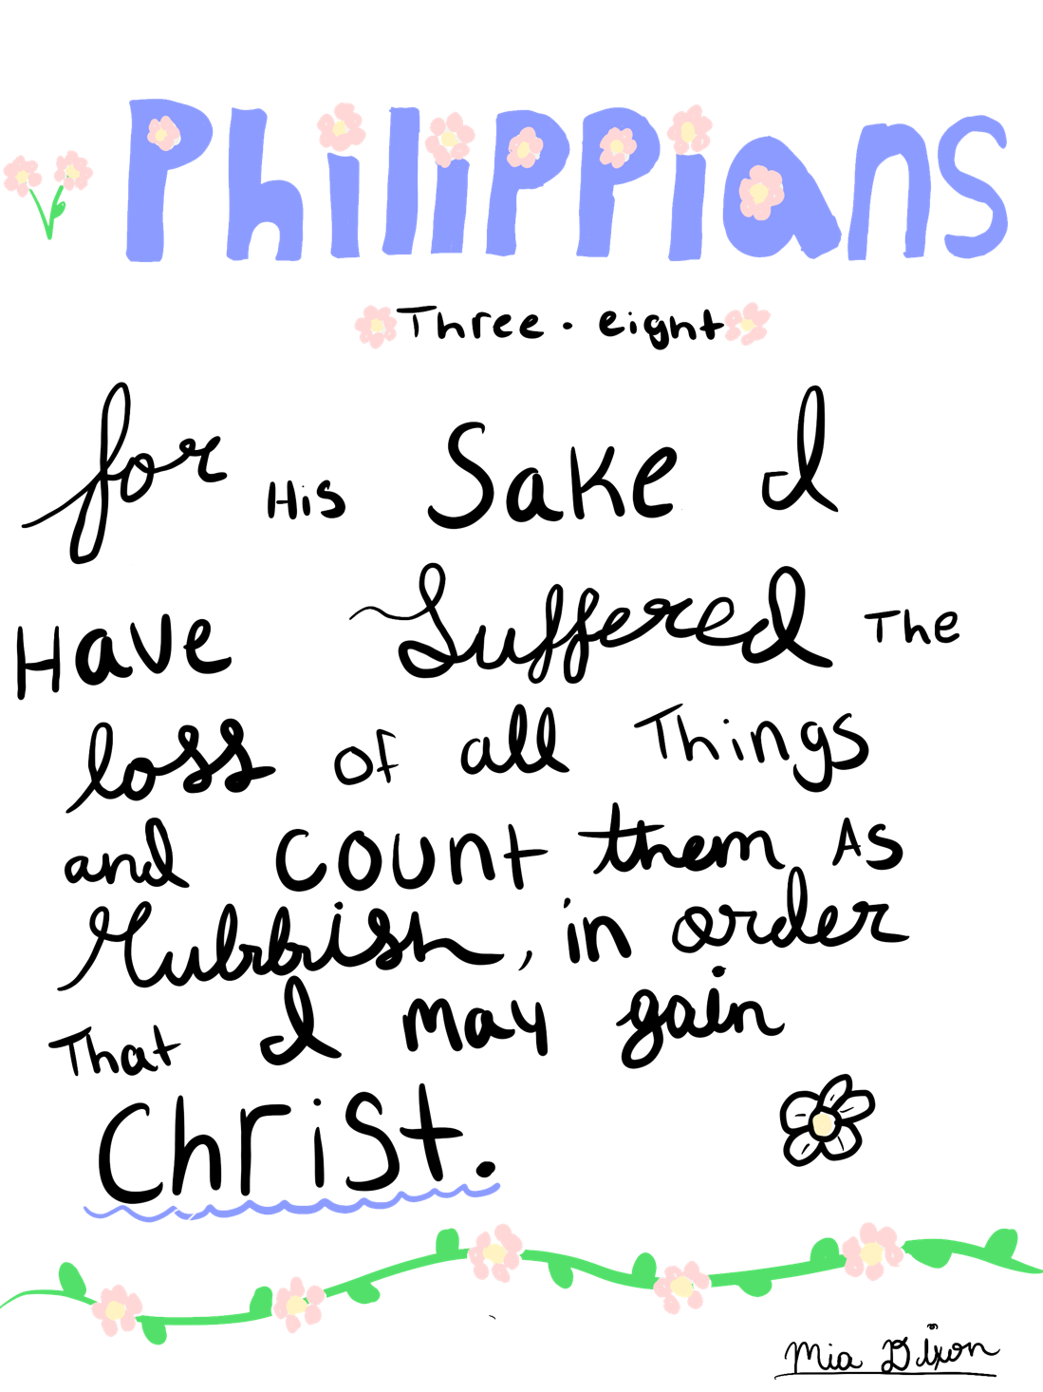

Day 3: Prioritizing His Words

Matt 7:24-27 “Everyone then who hears these words of mine and does them will be like a wise man who built his house on the rock. ²⁵ And the rain fell, and the floods came, and the winds blew and beat on that house, but it did not fall, because it had been founded on the rock. ²⁶ And everyone who hears these words of mine and does not do them will be like a foolish man who built his house on the sand. ²⁷ And the rain fell, and the floods came, and the winds blew and beat against that house, and it fell, and great was the fall of it.”

Imagine if we were people that had no knowledge of God and no access to His words. A world that existed without the idea of God but also no understanding of how we got here. Then imagine someone credible came to you and told you that there is a God who created all things, and He has written a book to explain the history of things, our nature, who He is and what He expects from us. I would say that most people in their right mind would make that book a must read. They would rush down to the local bookstore, buy it and begin to read it. Even if people couldn’t read, they would either get someone to read it to them or learn to read for themselves. I think it would be that important.
But we are not people without the Creator’s words. We have access to it constantly. There are people in other countries that do not. When they get their hands on it, they cling tightly to it. Because of our easy access to it, I do not think we realize how precious and important they are. His words are more important than anything you possess. They are even more precious than your life. Jesus illustrates the importance of them in this passage. He talks about a wise man and a foolish man. These are two different men with two different aspects on life. One man is very careful in how he builds his house. He goes to great lengths to build it in the proper place. The other man is flippant about building his house. He does not choose a proper location. He sets it on a foundation that is easily moved and not sturdy. He chose the sand.
We all know which house is the safer and more likely to last. The house built on the rock will withstand the storms. The one on the sand will not. Jesus speaks of rain and floods and winds. They beat against the houses. Only one remains. These elements are not the moral of the story. They represent the troubles and trials that will come our way. We will be faced with doubts and fears and uncertainties. Many of us will wonder what we should do next and how do we know the right way to go. Jesus is trying to help us see the path to the right destination. He says it is through His words.
When Jesus says this, it could have been taken as an arrogant statement. Who does He think He is telling people to hear His words and do them? Why are His words so important? Jesus knew who He was, and He knew the power of His word. He knew that it was at His word the world was created and men given life. He knew it was at His word nations rise and fall, storms rage and cease, and men live or die. His words are more important than gold or silver and sweeter than the sweetest of foods. Jesus knew these things. So, Jesus gives us instructions on how to handle His Word. He says, hear what I say and do it. This is how you can be wise.
We all want to be wise, don’t we? No one wakes up one day and says, “You know what self? I want to be an idiot today!” That has happened exactly zero times! The Bible actually says of itself in Psalm 19:7, “The law of the LORD is perfect, reviving the soul; the testimony of the LORD is sure, making wise the simple.” This is a perfect example of how God’s Word can transform our understanding and give us great wisdom. Please don’t walk through life lacking knowledge when it is so easily accessible to you.
Finally, it is one thing to read and hear His words, it is another thing to do them. It isn’t very wise to hear and even believe what Jesus says and then turn around and ignore it. That is the perfect example of foolishness. It is not easy to follow what Jesus has to say, but it is certainly worth the struggle. The good news is that those who are in Christ through faith, have the help of the Spirit of God in following His words. How important are the words of Jesus to you? How important are they really? Most of us have an overinflated sense of ourselves before God. If you were to judge yourself based on how much time you spend reading them, praying over them and actually living them out, how would you look? Pray and ask for God’s clarity on this and His help to create a love to read and obey his Word.

What did you learn and how do you apply it?

Breakout Session 3 – Morning

Colossians 3:1-3 If then you have been raised with Christ, seek the things that are above, where Christ is, seated at the right hand of God. ² Set your minds on things that are above, not on things that are on earth. ³ For you have died, and your life is hidden with Christ in God.

Biblical Example: Moses

Notes:

Breakout Session 4 – Evening

2 Timothy 2:19-22 ¹⁹ But God’s firm foundation stands, bearing this seal: “The Lord knows those who are his,” and, “Let everyone who names the name of the Lord depart from iniquity.” ²⁰ Now in a great house there are not only vessels of gold and silver but also of wood and clay, some for honorable use, some for dishonorable. ²¹ Therefore, if anyone cleanses himself from what is dishonorable, he will be a vessel for honorable use, set apart as holy, useful to the master of the house, ready for every good work. ²² So flee youthful passions and pursue righteousness, faith, love, and peace, along with those who call on the Lord from a pure heart.

Biblical Example: Disciples

Notes:

Day 4 Memory Verse



Day 4: Prioritizing Your Lives

2 Peter 3:11 Since all these things are thus to be dissolved, what sort of people ought you to be in lives of holiness and godliness,

Have you ever woken up one day and realized you had a project due or a big test to take? You had weeks to prep, but instead you filled your time with other things. Now the day is here, and you are completely unprepared. If you have never felt this feeling, count yourselves lucky. For most of us it is a familiar feeling. This is sort of the context behind what Peter is writing here. This verse sits in the middle of a chapter that begins with a warning. The warning is that there is a day coming when God will judge the world. It seems like it is off in the distance and will not come any time soon. This is our nature. We have a hard time considering the consequences in the future over the pleasures of the present.
Peter, who was one of Jesus’s Disciples is the one writing this letter. He spent a lot of time with Jesus. He heard many things from Jesus, and he is passing them down to people in different churches of his time and even writing these things for our sake today. It is nothing short of supernatural that we have these words preserved for us even today. In the beginning of the chapter, he tells them he is trying to stir up their minds and remind them of what is coming. He reminds them that people will come and scoff at the idea of God bringing judgment. People will doubt that Jesus is real and be sure that He will not come back. They will ask questions like, “Where is the promise of His coming?” They will say everything is the same as it was. They will deny things like the flood spoken of in the Bible. I have experienced these scoffers many times in my life, and I am sure you have as well.
But if you look and study you will see that there are signs of the flood everywhere. It is a constant reminder that God’s power is beyond anything we can imagine. This is important for us to realize. If not, we will live with no fear of God and be people unwise and unprepared for the day we must stand before Him. Peter warns that on that day it will be a terrible judgment. There will be a burning up and a dissolving of elements. He says that on that day the works done on this earth will be exposed. So, we learn there will one day be a reckoning. Just like there comes a day when you must face that test or that project.
Now, let’s look at verse 11 and what he is trying to get through to us. He is making the point that we have been warned of what is coming. And since we have been told and we know this is going to happen, then we must be mindful of the kind of person we are. For some of us, we may think we will not live until that day the Lord returns. This is a foolish thought. It doesn’t matter. One day sooner than any of us can imagine our life on this earth will end. Maybe the Lord is still being patient with those remaining on this earth. But one day we will stand before Him, and we can never know when that day may come. Peter is telling us we must consider this in our inner being.
Notice what He says here. He says, “What sort of people ought you to be in lives of holiness and godliness?” He is making such a strong point. This is one that he had wrestled with himself. He made the choice to be a Christ follower. When confronted by Jesus he left everything. He saw Jesus as better than anything the world offered. He also knew there was no other way. He faced trials and persecutions and death. He had answered the question as to what type of man he should be, and he lived it out. He focuses in on holiness and godliness. Holiness is the idea of being set apart as different from the world and common things and following hard after the ways of God. Godliness is living our lives in a godly manner. The idea here is that we filter all of our thoughts, actions and ways through a certain way of living. We ask the question, “Does this line up with what God wants from me?”
It is such a wise thing to prepare for that test, isn’t it? It is awesome when we wake up after a good night of sleep and know that we are fully prepared to take that test or present that project. Have you thought much of your life before God? Have you thought about what your life will look like on that day when God says your time on this earth is done? Being young makes it very difficult to consider such things. But I implore you to move beyond your youth. Think forward. Do the work. Some of the disciples were likely teenagers and the rest likely in their 20’s. Very early in their life they considered the future and made a decision to live lives that honored God. Will you do the same?

What did you learn and how do you apply it?

Breakout Session 5 – Morning

1Timothy 4:7-10 ⁷ Have nothing to do with irreverent, silly myths. Rather train yourself for godliness; ⁸ for while bodily training is of some value, godliness is of value in every way, as it holds promise for the present life and also for the life to come. ⁹ The saying is trustworthy and deserving of full acceptance. ¹⁰ For to this end we toil and strive, because we have our hope set on the living God, who is the Savior of all people, especially of those who believe.

Biblical Example: Shadrach, Meshac, Abednego

Notes:

Breakout Session 6 – Evening

Philippians 3:8-9 Finally, brethren, whatever is true, whatever is honorable, whatever is right, whatever is pure, whatever is lovely, whatever is of good repute, if there is any excellence and if anything worthy of praise, dwell on these things. ⁹ What you have learned and received and heard and seen in me—practice these things, and the God of peace will be with you.

Biblical Example: Paul

Notes:

Day 5 Memory Verse

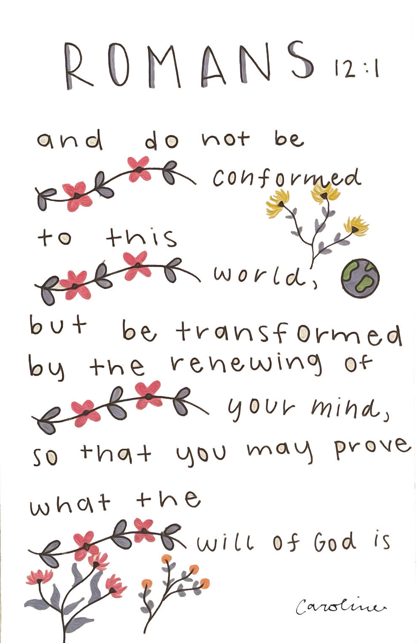

Day 5A: Prioritizing Devotion

Revelation 2:4-5 But I have this against you, that you have abandoned the love you had at first. ⁵ Remember therefore from where you have fallen; repent, and do the works you did at first. If not, I will come to you and remove your lampstand from its place, unless you repent.

I have always found these verses as particularly helpful for myself and the churches I serve. This section of scriptures come from the book of Revelation. It is called Revelation because it was Jesus “revealing” to us the future events that will come upon this earth. One of His disciples, John, is arrested and on an island called Patmos and Jesus appears again to him. John was one of Jesus’s closest and most faithful disciples. He was in prayer one day and Jesus appears to him and is about to give him a lot of information that he would write in a book and distribute to various churches. These churches needed an encouraging word from God because they were being strongly pursed and persecuted.
In the first 3 chapters we see Jesus addressing 7 of them particularly. A copy of this book would be sent to all seven of those churches. The passage we are studying today is written to a church in the city of Ephesus which in the country of Turkey today. He is writing to all of these churches things they are doing good and things they need to do better. By the time we get to these verses, Jesus has already commended them on their good works. Here he points out a very important area they needed to work on. He tells them that they had abandoned the love they had at first. From all we can gather, it seems they had lost the devotion they had for Him and His ways. They started out strong it seems. They loved Jesus and loved His ways. But for some reason or another their love had grown weak.
You may find this hard to understand. You may think that once you love something you will always love it. Well, that is true of God but not always of us. We often times struggle with our love and need God to help us even in loving Him. How many times have two people married and seemed so madly in love? Happens all the time in the movies. Happens often in real life as well. They fall in love and will do anything for each other. Eventually however, this “love” begins to lose some of its strength. The devotion to each other begins to wane. One day a person wakes up and doesn’t do the loving actions they used to do. The drive is gone.
I think this is what Jesus is getting at. He had told the disciples that if they loved Him, they would obey His commandments. Love is the great driver of action. Action is a great proof for love. This church was doing some really good things and for that Jesus commended them. But it seems their love was growing cold. It seems likely that their devotion to Jesus was not what it once was. What I mean is that their time focusing on His word and in prayer had likely begun to wane a bit. They were still going through the motions, but it wasn’t about love anymore. It was more about habit or keeping up appearances. We can understand the difference between doing a thing because we feel like we must versus doing something simply because we love it. I will happily walk up a mountain for a hike because I absolutely love being out in the mountains and hiking. But when I go to the gym and get on the stair climber, I dread it. I will still do it sometimes, but I do not love it.
This church had left the love they had at first. So, Jesus tells them they need to get back to love. Interestingly, He tells them to do the works they did at first. So, we learn that love is seen in actions. He says they must do what they previously did. First, he says they need to remember where they used to be, then they need to repent and finally they must do. This is the prescription to get us back on the right track. Jesus tells us that the greatest commandment is to love God with everything and the second is that we love our neighbor as ourselves. We are called to a life of love. Love is not simply an emotion. I would argue it goes way beyond an emotion. There is a lot more substance to it than that. Our emotions show our love. Our emotions also show joy. At times our emotions will show us what we hate. Love acts! It always has. There is no greater act than to love.
When we love, we display it in our devotion to the one we love. To prioritize our devotion to God is a great display of love. If you were honest, how devoted to Jesus would you say you are? Do you devote time, energy and action to Him? We find a great deal of things to devote ourselves to. Oh, that we would lay them down and find ourselves devoted to God in love! This is the call for us today. Will you answer that call?

What did you learn and how do you apply it?

Day 5B: Prioritizing the Fear of God

Ecclesiastes 2:1-3 I said in my heart, “Come now, I will test you with pleasure; enjoy yourself.” But behold, this also was vanity. ² I said of laughter, “It is mad,” and of pleasure, “What use is it?” ³ I searched with my heart how to cheer my body with wine—my heart still guiding me with wisdom—and how to lay hold on folly, till I might see what was good for the children of man to do under heaven during the few days of their life.

Ecclesiastes 12:13 The end of the matter; all has been heard. Fear God and keep his commandments, for this is the whole duty of man.

This is a very interesting book of the Bible. It is written by the son of King David. His name was Solomon. Solomon had everything this world had to offer. Everything. If you can name it, he had it or could get it easily. The book of Ecclesiastes is a book about the vanity of all the things that we can lay our hands on in this life. It is not just about material things but also about all the things that bring us pleasure. Solomon seems to take it as an experiment to test the goal and purpose of these things and where they lead.
In these first few verses in chapter 2 you can see what he tested. He tested himself with pleasures and enjoyment. He looked for things that made him laugh. He also used wine and grabbed onto things that were funny. He was looking for what was good for man to do during their life. If you read the whole book, you will learn that he tried making great works, gardens, buildings, pools, parks, herds, flocks, fruit trees, silver, gold. He also amassed a great deal of male and female slaves, singers, and concubines. He even tried out living wisely and learned a great many things. Then he tested out toil and labor. He looked into working hard in his life. In the end he learned that death comes to all. Death comes to the righteous as well as the wicked. He wondered about all of these things. He came to the realization that all of the things we put our hearts, minds and hands to are vanity.
When he says they are vanity he means they are empty and mean nothing. He is trying to drive home the point that the things of this world will never fully satisfy or leave a legacy. You do these things, and then those after you and then those after them and even those that came before do the same. He makes the point that there is nothing new under the sun. We continue as people in the same manner. We try to use the things around us to find delight and make names for ourselves. In the end they will never do.
There is another route we can take. And we can even find pleasure in the things around us if we go about them the right way. Toward the end of the book in chapter 12 he gives us the key to life. He says, The end of the matter; all has been heard. Fear God and keep his commandments, for this is the whole duty of man. The fear of God begins wisdom. Fear is meant to explain an attitude of reverence and honor that we give to Him. He is trying to teach us that this is where we find purpose and legacy. This is where we can make our lives count. Do you want to live a life that counts? Spend your days in all you do within them walking in the fear of God. The goal and purpose of man is to reflect the image of God to the world around us. So, if you work let it be for God. If you play let it be for God. If you eat or drink or speak or any other such thing, let it be for God.
We have talked all week about priorities. When we fear God as we should, it makes it much easier for us to put our priorities in order. Walking with and fearing God puts a drive within us to prioritize all the right things in all the right ways. I want you to take some time and consider your life as you head back home. How do you normally live it? What habits will you change? How will you order your days differently so you may put things in the right order? I believe I said previously that we all have priorities. We all put something first. The question we must ask ourselves is if they are the right things. If they are not, then how do you rearrange things, so you walk as a person reflecting the image of God?

What did you learn and how can you apply it?

