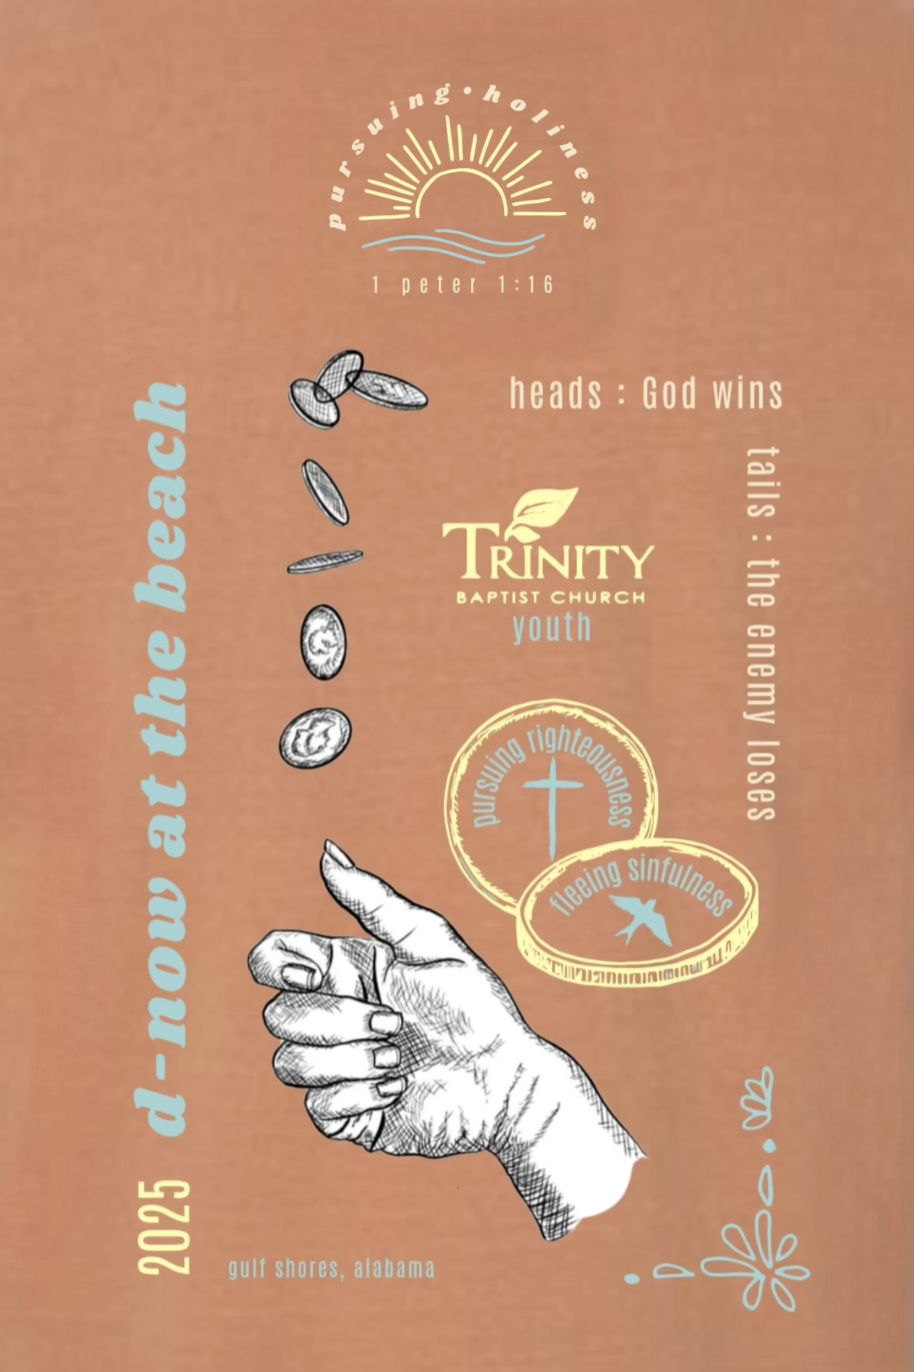
1





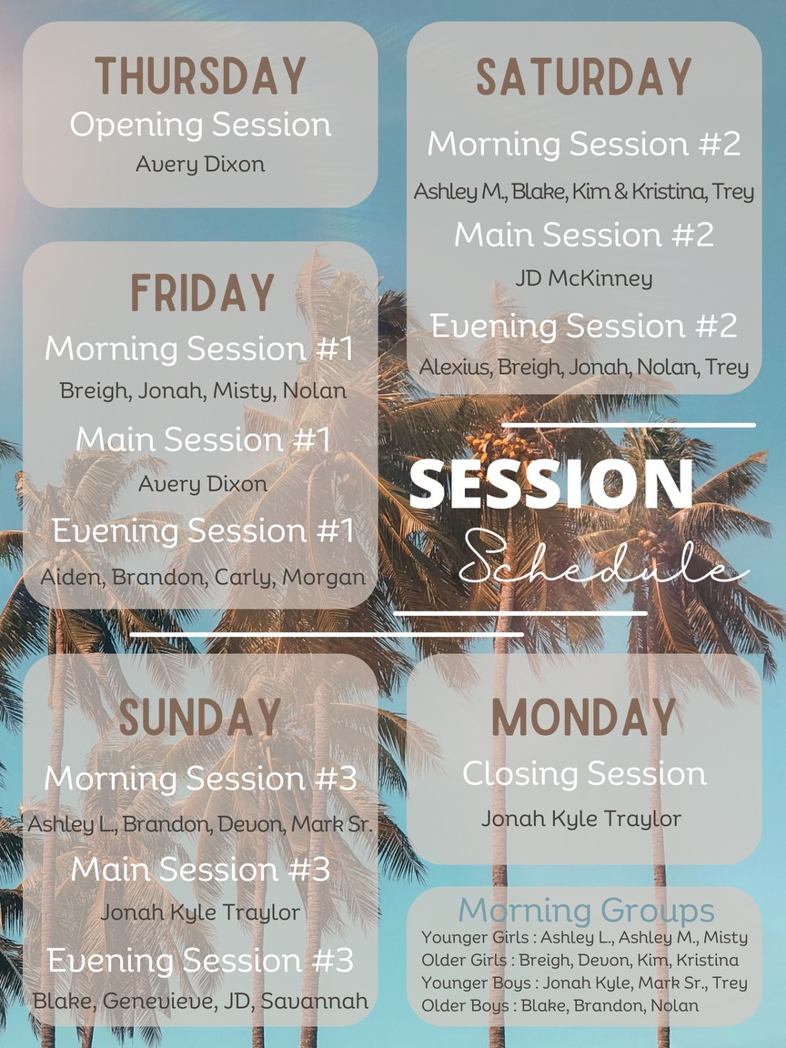



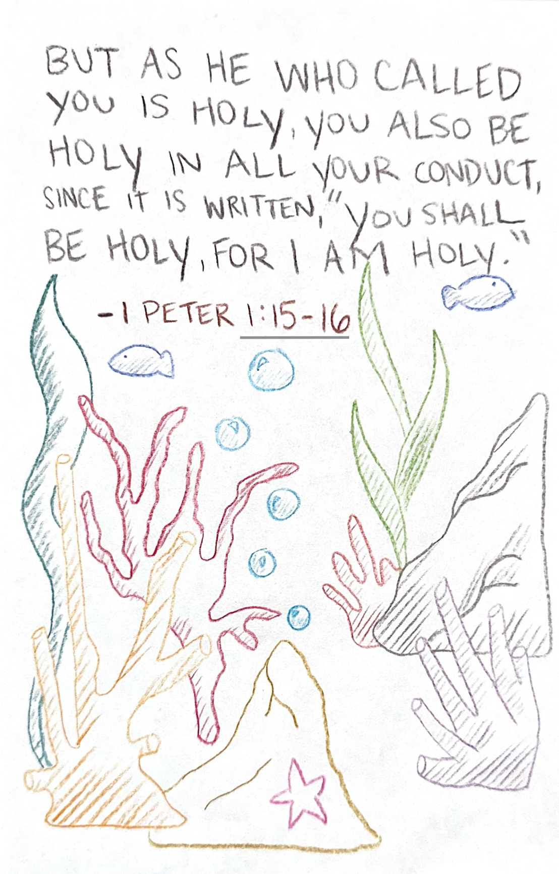
Thursday Memory Verse

Thursday AM Devo:

1 Peter 1:14-16 As obedient children, do not be conformed to the passions of your former ignorance, but as he who called you is holy, you also be holy in all your conduct, since it is written, “You shall be holy, for I am holy.”‬‬‬

By Faith:

In a world where we are constantly being shaped by culture, media, and peer pressure, 1 Peter 1:14-16 is a divine call to live differently. In these verses, Peter is reminding us that being a child of God comes with a new identity and a new way of living. Before we knew Christ, we lived according to our own desires, often unaware of the damage sin caused. But now, as God’s beloved children, we are called to live differently—to reflect His character in every part of our lives.
Holiness isn’t about being perfect in our own strength—it’s about being set apart, living with a heart surrendered to God. Just as God is holy, He calls us to mirror that holiness in our thoughts, words, and actions. This isn’t a command to strive for unreachable moral perfection, but an invitation to walk daily with the One who transforms us.
God doesn’t just suggest holiness; He commands it. “Be holy, for I am holy.” This isn’t about living flawlessly, but about living faithfully—set apart for God’s purposes, shaped by His truth, and empowered by His Spirit. Although the end goal is living flawlessly, it takes faithfulness to get there.
When we choose obedience, turning from the ways we once walked in, we honor the One who saved us. Holiness isn’t a burden—it’s the beautiful evidence that we belong to Him. In 1 Peter 1:16, Peter is referencing the book of Leviticus to show that God’s children have always been called to be holy as God is holy. Leviticus 11:44 “For I am the Lord your God. Consecrate yourselves therefore, and be holy, for I am holy…”
Consecrate meaning set apart. Similarly Leviticus 20:26 says about the Israelites(God’s chosen people), “You shall be holy to me, for I the LORD am holy and have separated you from the peoples, that you should be mine.”
The Israelites are symbolic of us (anyone who surrenders their life to God).
Paul speaks about a similar notion(being set apart from the world) in Romans 12:2 – “Do not conform to the pattern of this world, but be transformed by the renewing of your mind…” Holiness begins with the way we think. As we allow God’s Word to renew our minds, our desires and behaviors change to reflect His character.

Reflection Questions:
- What are some “former passions” or habits that God is calling you to leave behind?
- How can you reflect God’s holiness in your daily life—at work, home, and in your thoughts?
- Are there areas in your conduct where God is inviting you to grow in purity and obedience?

What did you learn and how can you apply it?

Thursday Main Session Notes
“God is Holy”

Isaiah 6:1–5 (ESV) — 1 In the year that King Uzziah died I saw the Lord sitting upon a throne, high and lifted up; and the train of his robe filled the temple. 2 Above him stood the seraphim. Each had six wings: with two he covered his face, and with two he covered his feet, and with two he flew. 3 And one called to another and said: “Holy, holy, holy is the Lord of hosts; the whole earth is full of his glory!” 4 And the foundations of the thresholds shook at the voice of him who called, and the house was filled with smoke. 5 And I said: “Woe is me! For I am lost; for I am a man of unclean lips, and I dwell in the midst of a people of unclean lips; for my eyes have seen the King, the Lord of hosts!”

2 Samuel 6:6–7 (ESV) — 6 And when they came to the threshing floor of Nacon, Uzzah put out his hand to the ark of God and took hold of it, for the oxen stumbled. 7 And the anger of the Lord was kindled against Uzzah, and God struck him down there because of his error, and he died there beside the ark of God.

Leviticus 10:1–3 (ESV) — 1 Now Nadab and Abihu, the sons of Aaron, each took his censer and put fire in it and laid incense on it and offered unauthorized fire before the Lord, which he had not commanded them. 2 And fire came out from before the Lord and consumed them, and they died before the Lord. 3 Then Moses said to Aaron, “This is what the Lord has said: ‘Among those who are near me I will be sanctified, and before all the people I will be glorified.’ ” And Aaron held his peace.

Notes:

Thursday PM Devo:

Proverbs 1:7 “The fear of the Lord is the beginning of wisdom, and the knowledge of the Holy one is insight.”

By Mia:

First let’s talk about what the fear of the Lord truly is. The fear of the Lord is not necessarily being afraid of God, although there is a sense that we ought to be. God creates and He destroys and He is sovereign over all things, so to fear him means to have profound respect and reverence for Him. It is to be in awe of his majesty and holiness while recognizing his authority to do as he pleases. This brings us to a place of humility and a proper recognition of who we are. This is a reverence that acknowledges Gods authority and leads us to humility and obedience rather than our human nature of pride and rebellion.
Also, in Proverbs 1:7, "The fear of the Lord is the beginning of knowledge," is highlighting that wisdom starts with recognizing God's sovereignty. The “knowledge of the holy one” refers to an understanding that comes with a personal relationship with God. This knowledge goes beyond our human understanding, it involves a much deeper knowing that comes from this personal relationship with God. As we develop this relationship, it shapes our thoughts and actions and we begin to change from the inside out. If you’ve ever heard the phrase: “you are who you hang around,” you may have brushed it off and never given it much mind. However, it could not be more true. When you immerse yourself in God’s word, in prayer, and in praise, you become more like him. Your wants and desires become aligned with His will the more He changes you.
This is the true wisdom which comes from truly knowing God in all His glory. This doesn’t mean you’re the most academically smart or you know all these big words or whatever, instead wisdom comes through fear of God which leads to changed thoughts and actions. Wisdom and understanding mean we have true insight that comes from a right relationship and recognition of God. This means a person’s mind is shaped by God’s reveled will. This journey to wisdom and understanding begins with a proper fear of God. Fear of God produces respect, honor, reverence, and obedience towards Him.
To apply this verse in our lives would mean that we walk in humility as we desire our wants to be aligned with his will. This could start with a simple prayer asking that He give you the desire to do what He wants you to do as you seek His will in His Word. Seeking wisdom means to seek a relationship with God through prayer, study, and obedience as we remember fear of the lord creates the wisdom.
So, the central theme of this verse is not our desire of wisdom, but a desire to fear him appropriately. By doing this, we can gain understanding that leads to a life of integrity and longing for knowledge. Proverbs 9:10 teaches that true wisdom begins with a reverent fear of the Lord and is deepened by a strong knowledge of his nature. This leads to understanding that fuels our new desire to live a righteous life.

What did you learn and how can you apply it?

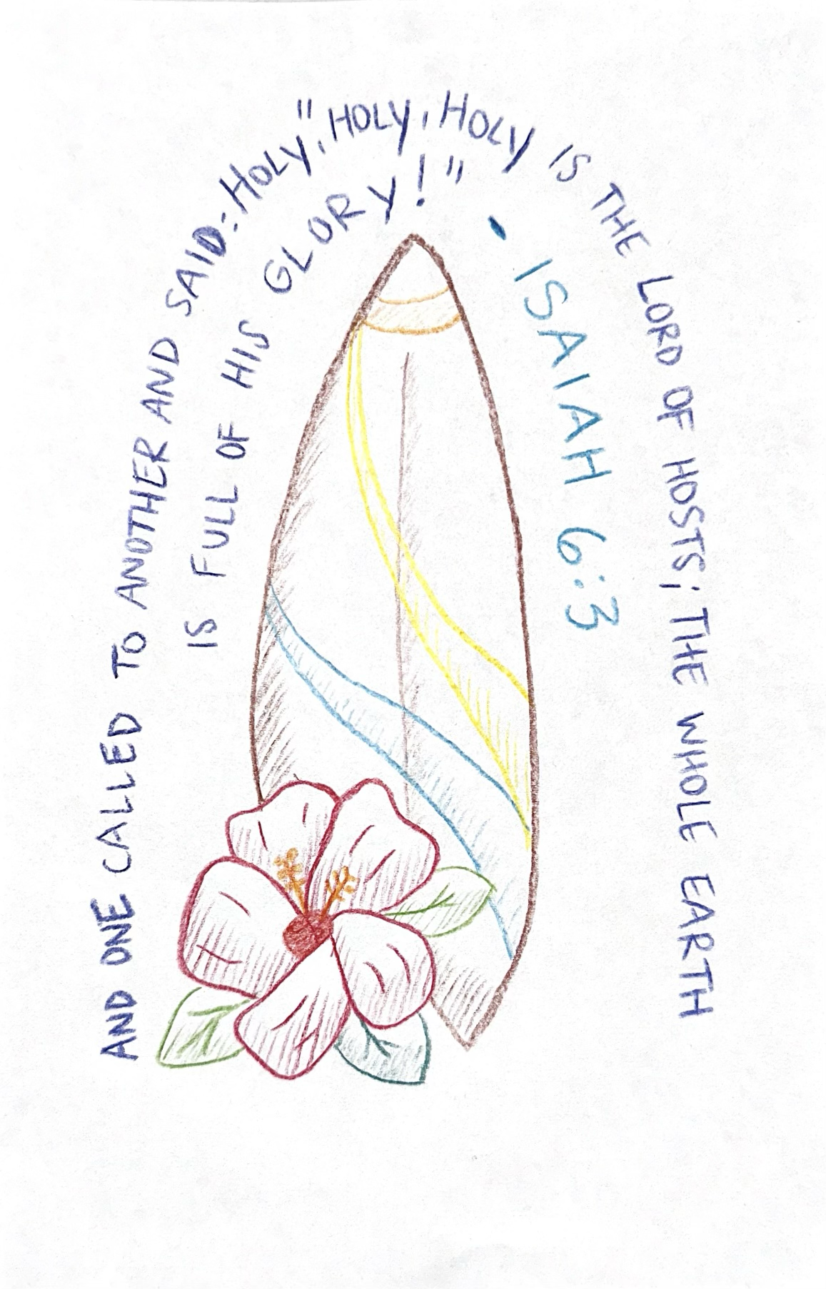
Friday Memory Verse

Friday Am Devo

Psalm 128:1 “Blessed is everyone who fear the Lord, Who walks in His ways”

By Brandon

It's day 2 of this D-NOW trip. I hope you’re having fun and learning what it means to pursue holiness. I know things might be a little chaotic but keep pushing through! Anyway, let’s take a look at Psalm 128!
We aren’t too sure who the author of this psalm is, but it is titled “A Song of Ascents.” This could mean it was a psalm written to be used as worship by the Israelites on their way to Jerusalem. Notice the psalmist says that a person who fears the LORD is blessed. What does it mean to fear the LORD though? Does this mean that we are to run away and scream in fear as if our lives were in danger? Not at all. When the psalmist says to fear the LORD, they mean to acknowledge God’s authority over our lives. Think about it, God is the creator of the universe, over all things. He has the right to give and to take away. He is all-knowing and all-powerful. Who are we to act as if we have more power than God, and that our actions are beyond his judgment. By fearing God, we acknowledge that he is the supreme judge over our lives and that we can’t live as if there are no consequences to our actions.
The psalmist also says that a person who walks in God’s ways is blessed. In order to walk in God’s ways, we need to take a look at what His ways are. The best way to do that is by looking at the gospels that document Jesus’ life. We know first of all, Jesus lived a perfect and sinless life. That is setting the bar to an extreme high, so extreme that it is actually impossible to reach. We can never be perfect on our own, but this doesn’t give us a reason to just give up. Pursuing holiness isn’t about perfection, it is about being more Christ-like. We will make mistakes, but when we recognize our mistakes and go to Jesus for forgiveness, it makes us grow. Jesus’ disciples weren’t perfect either, Peter denied Jesus three times, but they were forgiven and strived to live a life that was close to how Jesus lived his. They listened to Jesus’ teachings and commandments and took them to heart. They made it their goal to live that way. That is why it is important to read the gospels and see how Jesus lived his life. We, like the disciples, need to make it our goal to live more like our master.
The psalmist says these people are blessed. When you fear God and give him the respect that he rightfully deserves and walk in the way that he came down on earth and set before you, you will grow your relationship with God. God himself will dwell within your heart and help guide you to live an even more holy life. With his influence, you’ll truly start living more like Jesus, and this pleases God. You are recognizing that your sinful life and the kingdom you have been building for yourself is nothing compared to God’s kingdom, and because of that, we receive God’s love, mercy, and grace. These are all his blessings. Before I close, I want to share something my grandpa told me before he died. (If you want to hear about my grandpa’s story please ask.) He said, “The more life is about me, the worse it is. The more life is about Jesus, the better it is.” The disciples made it their goal to make their lives more like Jesus’ and because of their faith, they get to spend eternity with their creator in paradise. Take some time and think about some areas in your life that you can model to be more like Jesus.

What did you learn and how can you apply it?

Friday Am Breakout Session
(Misty, Breigh, Jonah Kyle, Nolan)

Luke 5:4–8 (ESV) — 4 And when he had finished speaking, he said to Simon, “Put out into the deep and let down your nets for a catch.” 5 And Simon answered, “Master, we toiled all night and took nothing! But at your word I will let down the nets.” 6 And when they had done this, they enclosed a large number of fish, and their nets were breaking. 7 They signaled to their partners in the other boat to come and help them. And they came and filled both the boats, so that they began to sink. 8 But when Simon Peter saw it, he fell down at Jesus’ knees, saying, “Depart from me, for I am a sinful man, O Lord.”

Notes:

Friday Main Session Notes

2 Peter 1:3–4 (ESV) — 3 His divine power has granted to us all things that pertain to life and godliness, through the knowledge of him who called us to his own glory and excellence, 4 by which he has granted to us his precious and very great promises, so that through them you may become partakers of the divine nature, having escaped from the corruption that is in the world because of sinful desire.

Friday Pm Breakout Session
(Aiden, Brandon, Carley, Morgan, Savannah)

Notes:

Friday Pm Devo

Titus 2:11-14 “For the grace of God has appeared, bringing salvation for all people, training us to renounce ungodliness and worldly passions, and to live self-controlled, upright, and godly lives in the present age, waiting for our blessed hope, the appearing of the glory of our great God and Savior Jesus Christ, who gave himself for us to redeem us from all lawlessness and to purify for himself a people for his own possession who are zealous for good works.”

By JD

In these verses, Paul is writing to Titus, instructing him and his companions in sound doctrine. He is teaching them how to live as holy witnesses of their faith. Paul presents a list of qualities that describe those who profess to know God:
- We are to renounce ungodliness.
- We are to renounce worldly passions.
- We are to live self-controlled lives.
- We are to love upright lives.
- We are to live godly lives.
- We are to be zealous for good works.

As we reflect on this passage, we should recognize that we are being trained in these things. Verse 12 states, "training us to..." and then he outlines what we should remove from our lives and how we should live instead. Paul acknowledges that, although our lives have been crucified with Christ, we still face a daily battle—turning away from unrighteousness and turning to righteousness. He understands that this transformation requires training, implying that it takes time, careful attention, planning, effort, sacrifice, and a deep motivation for why we pursue it.
When we consider training in sports, we see similar qualities. Take a baseball player, for example: he dedicates time to practice, focuses carefully on developing his skills, follows a strategic plan for each game, endures difficult training sessions, makes sacrifices to excel, and is ultimately driven by a goal that fuels his dedication.
Likewise, for someone who desires to follow Jesus wholeheartedly, the same principles apply. Growing in faith requires dedicating time to know Christ and share Him with others. It takes careful attention to draw near to God while resisting temptation. We need a structured plan to pursue Jesus intentionally; if you fail to plan, you are planning to fail. There will be difficult moments along the journey—Jesus never promised an easy life, but He did promise eternal life. Following Jesus also demands sacrifice—giving up worldly desires, getting rid of certain comforts, and surrendering time and effort for the sake of honoring Him. Ultimately, our reason for living in this way is the grace of God, which has appeared to us.
What makes this passage truly beautiful is that it is framed by the Gospel itself. Before instructing us on how to live, Paul first declares, "The grace of God has appeared, bringing salvation to all people." He reminds us of the undeserved gift we have received, emphasizing that our righteous actions are merely a response to grace.
Paul then brings everything back to the Gospel: We are waiting for our blessed hope! We eagerly anticipate the glorious return of our great God and Savior, Jesus Christ, when He will bring us home into His eternal Kingdom.
Finally, Paul reminds us that Jesus, our Savior, gave Himself for us. He sacrificed Himself to redeem us from all wrongdoing and purify us before God, so that we may belong to Him and serve Him faithfully.

What did you learn and how do you apply it?

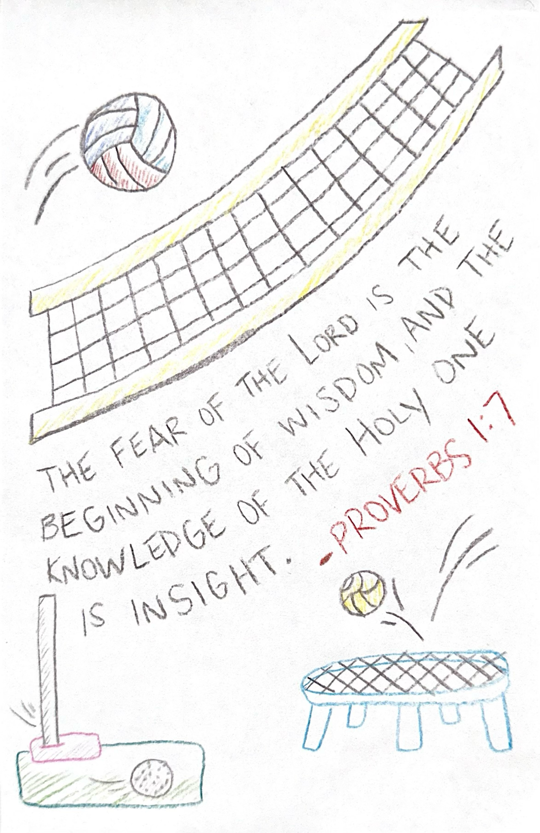
Saturday Memory Verse

Saturday Am Devo

Hebrews 12:14 “Strive for peace with everyone, and for the holiness without which no one will see the Lord.”

By Faith:

The book of Hebrews was written to believers who were facing persecution, discouragement, and the temptation to drift away from the faith. In chapter 12, the writer encourages them to endure discipline and stay the course, fixing their eyes on Jesus who is the “author and finisher of our faith” (Hebrews 12:2). Verse 14 serves as a pivotal exhortation, urging believers toward both relational peace and personal holiness—two inseparable aspects of a vibrant, God-honoring life.

1. “Pursue peace with all people” — A Call to Relational Integrity

The word “pursue” implies intentionality and effort. Peace doesn’t always come naturally; it often requires deliberate action, humility, and forgiveness. The directive to pursue peace is universal—not just with those we like, agree with, or who treat us well, but with all people.

a. Peace Is a Fruit of the Spirit

Galatians 5:22 lists peace as a fruit of the Spirit. This tells us that true peace flows from a Spirit-led life. It’s not just about external harmony but an internal disposition shaped by Christ’s love.

b. The Peacemaker’s Reward

Jesus said in Matthew 5:9, “Blessed are the peacemakers, for they shall be called sons of God.” When we work toward peace, we mirror God’s heart. The ministry of reconciliation (2 Corinthians 5:18) is central to the gospel.

c. Peace Is Not Always Possible—but Always Pursued

Romans 12:18 wisely adds, “If it is possible, as much as depends on you, live peaceably with all men.” Peace cannot be forced, but it must always be sought. Even in the face of rejection or conflict, we are responsible for our end of the relationship.

2. “And holiness” — A Call to Personal Purity

The pursuit of peace must be balanced with the pursuit of holiness. Holiness here refers to being set apart for God—living in moral purity, obedience, and reverence. It’s not optional for believers; it’s the very essence of our calling.

a. Holiness Reflects God’s Character

1 Peter 1:15-16 says, “Be holy, for I am holy.” Holiness is not merely about avoiding sin; it’s about reflecting the nature of God. We are called to live lives that are distinct from the world—lives that shine with the light of Christ.

b. Holiness Is a Process and a Pursuit

While we are positionally made holy through Christ (Hebrews 10:10), we are also called to grow in holiness daily (1 Thessalonians 4:3). This process, called sanctification, involves dying to self and being transformed into Christ’s image.

c. Holiness Enables Fellowship with God

The verse states soberly: “without which no one will see the Lord.” This is not about earning salvation but evidencing it. A life devoid of holiness indicates a heart untouched by grace. Holiness is the environment in which communion with God flourishes, because He is Holy.

3. The Interplay Between Peace and Holiness

These two pursuits—peace and holiness—are deeply connected. One without the other leads to imbalance:

- Peace without holiness can become compromise. We may shy away from truth to avoid conflict.
- Holiness without peace can become self-righteousness. We may stand for truth but lack love and gentleness.

Together, they form the Christ-like life: full of grace and truth (John 1:14). Jesus lived in perfect holiness and still dined with sinners. He never sinned, yet extended peace to the unworthy. He is our model.

Application: Living Out Hebrews 12:14
- Examine Your Relationships
Are there people with whom you need to pursue peace?
Are you quick to forgive, slow to anger, and ready to reconcile?
- Evaluate Your Walk in Holiness
Are you intentionally turning from sin?
Do your thoughts, words, and actions reflect the purity of Christ?
- Recommit to the Pursuit
Peace and holiness are lifelong pursuits.
Pray daily for the Spirit’s help to walk in both.

Conclusion

Hebrews 12:14 is a concise yet powerful reminder of the Christian’s dual call: to be right with others and to be right with God. It challenges us to active love and personal transformation. In a world marked by strife and moral confusion, may we be a people known for our peace and holiness—because in this, we not only reflect the Lord, but we make Him known.

What did you learn and how do you apply it?

Saturday Am Breakout Session
(Ashley L, Devon, Mark, Brandon)

Job 1:6–12 (ESV) — 6 Now there was a day when the sons of God came to present themselves before the Lord, and Satan also came among them. 7 The Lord said to Satan, “From where have you come?” Satan answered the Lord and said, “From going to and fro on the earth, and from walking up and down on it.” 8 And the Lord said to Satan, “Have you considered my servant Job, that there is none like him on the earth, a blameless and upright man, who fears God and turns away from evil?” 9 Then Satan answered the Lord and said, “Does Job fear God for no reason? 10 Have you not put a hedge around him and his house and all that he has, on every side? You have blessed the work of his hands, and his possessions have increased in the land. 11 But stretch out your hand and touch all that he has, and he will curse you to your face.” 12 And the Lord said to Satan, “Behold, all that he has is in your hand. Only against him do not stretch out your hand.” So Satan went out from the presence of the Lord.

Notes:

Saturday Main Session
“Not Like the World”

Romans 6:1–14 (ESV) — 1 What shall we say then? Are we to continue in sin that grace may abound? 2 By no means! How can we who died to sin still live in it? 3 Do you not know that all of us who have been baptized into Christ Jesus were baptized into his death? 4 We were buried therefore with him by baptism into death, in order that, just as Christ was raised from the dead by the glory of the Father, we too might walk in newness of life. 5 For if we have been united with him in a death like his, we shall certainly be united with him in a resurrection like his. 6 We know that our old self was crucified with him in order that the body of sin might be brought to nothing, so that we would no longer be enslaved to sin. 7 For one who has died has been set free from sin. 8 Now if we have died with Christ, we believe that we will also live with him. 9 We know that Christ, being raised from the dead, will never die again; death no longer has dominion over him. 10 For the death he died he died to sin, once for all, but the life he lives he lives to God. 11 So you also must consider yourselves dead to sin and alive to God in Christ Jesus. 12 Let not sin therefore reign in your mortal body, to make you obey its passions. 13 Do not present your members to sin as instruments for unrighteousness, but present yourselves to God as those who have been brought from death to life, and your members to God as instruments for righteousness. 14 For sin will have no dominion over you, since you are not under law but under grace.

Notes:

Saturday Pm Breakout Session
(Alexius, Blake, Emily, Genevieve, Trey)

Notes:

Saturday Pm Devo

Ephesians 4:22-24 “to put off your old self, which belongs to your former manner of life and is corrupt through deceitful desires, and to be renewed in the spirit of your minds, and to put on the new self, created after the likeness of God in true righteousness and holiness.”

By Faith:
In these verses, Paul gives a picture of the Christian life that is both immediate and ongoing. The moment we trust in Christ, we are saved—but sanctification, the process of becoming more like Him, is a lifelong journey.
Hebrews 10:14 says, “For by one sacrifice he has made perfect forever those who are being made holy.” It’s not about a one-time change but about continually putting off the old and putting on the new, day by day, choice by choice.
Sanctification is God’s work in us, through the Holy Spirit, making us holy in practice as we already are in position through Christ. It begins with a new heart, but it unfolds as we cooperate with the Spirit—renewing our minds, resisting old patterns, and choosing God’s way over our own.
Paul describes this process vividly. We are to put off the old self v.22, which is being corrupted—not just once, but continually. This implies a daily surrender of the habits, thoughts, and desires that reflect who we were without Christ. Colossians 3:5 says, “Put to death, therefore, whatever belongs to your earthly nature: sexual immorality, impurity, lust, evil desires and greed, which is idolatry.”
We then are to be renewed in the attitude of our minds v.23—allowing God’s truth to reshape our perspectives, motivations, and values. Finally, we put on the new self v.24, which is not something we create but something God has already created within us. This new self reflects His image in true righteousness and holiness v.24, and we grow into it more fully with each step of obedience.
Sanctification doesn’t mean perfection overnight—it means progress. It’s a grace-filled transformation where God patiently molds us into the likeness of Christ.
Application:
- Recognize the process.
Be patient with yourself in the journey. Growth in holiness is gradual, and God is faithful to complete what He began in you (Phil. 1:6).
2. Participate intentionally. Sanctification involves your daily cooperation. Identify one “old self” attitude or behavior the Spirit is prompting you to surrender today.
3. Renew your mind with truth. Let Scripture be your mirror. Spend time daily in God’s Word to align your thoughts with His.

What did you learn and how do you apply it?
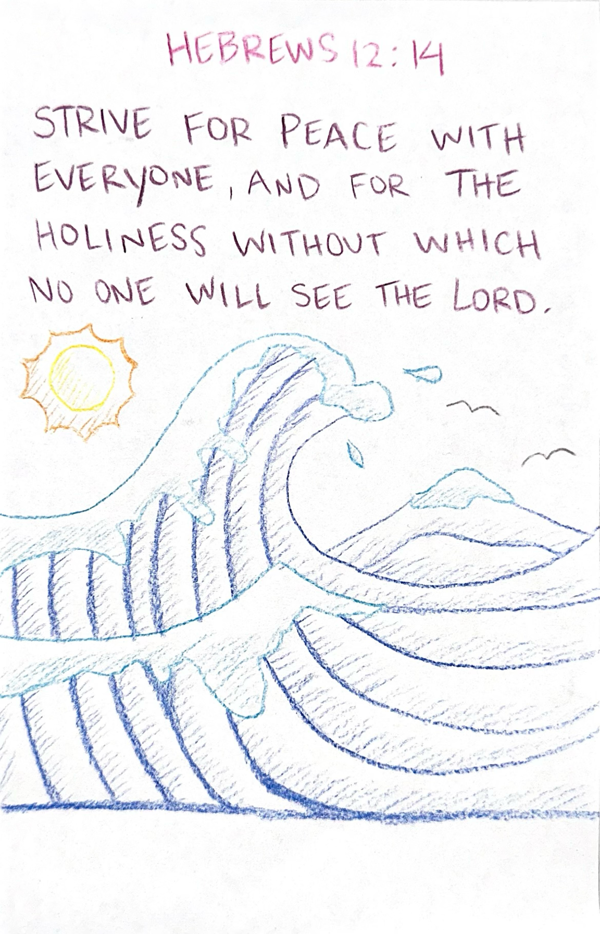
Sunday Memory Verse

Sunday Am Devo

Psalm 24:3-4 “Who shall ascend the hill of the Lord? And who shall stand in his holy place? He who has clean hands and a pure heart, who does not lift up his soul to what is false and does not swear deceitfully.”

By Lane:

A Hill Climbed by the Unworthy
If you have ever climbed a hill, you know It takes effort. Your legs get tired, you sweat, and sometimes you wonder if the view is even worth it. But when you reach the top and see the view. Suddenly, all the work it took to get there makes sense. Psalm 24 talks about a different kind of climb: “Who may ascend the mountain of the Lord?” In other words, who can get close to God? Who gets to stand in His presence?
This is not just a question for adults or super-religious people, it’s for you. It’s for students, teenagers, and anyone who wants to know: How can I truly live for God?
“Who shall stand in His holy place” is asking us are we truly living a life that is deserving of dwelling in the place of the Lord, or do we live our life thinking we are because we “believe in God” or are “good people”. Romans 3:10-12 says that “None is righteous, no, not one; no one understands; no one seeks for God. All have turned aside; together they have become worthless; no one does good, not even one.”
So, ask yourself, “Am i good person or do i just think i am?” We can’t base the goodness of our life on earthly things. We must structure it on Gods standard of good. If we do that, we will find the answer and realize that none of us are good or even ok on our own. Romans 3:23 says “For all have sinned and fall short of the glory of God.” Verse 4 of Psalm 24 explains some of the things that those desiring to know God should do.

- Clean Hands: What You Do Matters

“Clean hands” isn’t just about washing before dinner. It means living a life where your actions reflect God’s values. Think of it this way:
• Are you treating others with respect, even the ones who are hard to love?
• Are your words building others up, or tearing them down?
• When no one is watching, are your choices still honoring to God?
It doesn’t mean being perfect, which none of us are, but it does mean being real. It means choosing what’s right even when it’s hard, and being willing to make things right when you mess up. We shouldn’t be ok with the sin in our life. Our sin destroys us spiritually and sometimes physically. Our sin also separates us from God, blinding us from Him.

2. Pure Heart: What’s Going on Inside Counts

A “pure heart” is about what’s happening beneath the surface. Maybe you’ve been doing all the “right” things on the outside such as going to church, saying the right words, but inside, your heart is bitter, jealous, prideful, or even just far from God.
A pure heart doesn’t mean a perfect heart. It means a heart that is fully open to God, wanting to be honest, to grow, and to love Him for real. Psalm 55:22 says that we should “Cast your burden on the Lord and he will sustain you”. If we truly give up our old selves and are born again through Christ, though it can be hard, our eternal lives will change for the better and you will never look back. We will fall and stumble but instead of us trying to get up on our own we turn to God and He is there helping us through everything.
If it seems as if this is an impossible task, that is because it is on your own. The only way to truly have clean hands and a pure heart that is able to ascend the hill of the Lord is to be covered by the blood of Jesus. It is only when we are in Christ that we are made pure. It is then we are enabled to live out the clean hands and pure hearts as He enables us through the power of His Spirit.

Ask yourself:
• What do I care about most?
• Do I want to please God or just impress people?
• Am I chasing what’s temporary, or am I living for something eternal?

3. No Idols: Where Do You Put Your Trust?

The psalm says this person “does not trust in an idol or swear by a false god.” That might sound ancient, but idols today are just as real. They’re anything we look to for meaning, identity, or security that isn’t God. What could that be for you? Popularity? Appearance? Social media? Relationships? Success or grades?
None of those things are bad in themselves, but when they become your everything, they can slowly take God’s place in your heart. Idols can’t save us. They can’t forgive us. They can’t love us the way Jesus does. Idols are temporary happiness for a life long of un satisfaction and no fulfillment. Psalm 23:1 says that “The Lord is my Shepherd; I shall not want”. If we let God guide us and be the top priority in our lives then we will find ourselves not desiring things of this world that leave us wanting more.

What did you learn and how do you apply it?

Sunday Am Breakout Session
(Ashley M, Kim, Trey, Blake)

Galatians 1:15–16 (ESV) — 15 But when he who had set me apart before I was born, and who called me by his grace, 16 was pleased to reveal his Son to me, in order that I might preach him among the Gentiles, I did not immediately consult with anyone;

Notes:

Sunday Main Session
“The Holiness of the Cross”

Romans 3:25–26 (ESV) — 25 whom God put forward as a propitiation by his blood, to be received by faith. This was to show God’s righteousness, because in his divine forbearance he had passed over former sins. 26 It was to show his righteousness at the present time, so that he might be just and the justifier of the one who has faith in Jesus.

Notes:

Sunday Pm Breakout Session
(Arynn, Breigh, James, Kelsey, Nolan)

Notes:

Sunday Pm Devo

Matthew 5:8 “Blessed are the pure in heart, for they shall see God”

By Savannah

In a world full of distractions, pressures, and temptations, the idea of having a pure heart can feel impossible. But Jesus reminds us that those who pursue purity will experience the incredible blessing of seeing God.
Having a pure heart isn’t just about looking good on the outside or following a set of rules. It’s about a deep, inner transformation—a heart free from selfish motives, distractions, and divided loyalties. A pure heart is fully committed to God, seeking Him with everything—mind, body, and soul.
When we allow His truth to shape our thoughts, desires, and actions, we begin to reflect His love, His truth, and His holiness. This isn’t something we achieve overnight. Being fully aligned with God is a lifelong process—one made possible through His grace. It requires surrender, trusting Him to refine our hearts, and a daily commitment to seek Him. But in doing so, we find true joy—walking closely with Him, seeing Him more clearly, and becoming more like Christ.

Seeing God in Everyday Life
Seeing God isn’t just something that happens in heaven—it’s a present reality. When we let go of the sin and distractions clouding our hearts, we can recognize His presence in our daily lives:

● Answered Prayers: One of the most obvious ways we see God is through answered prayers. Sometimes the answer looks exactly like we hoped, and other times it doesn’t. But even when things don’t go our way, God is still working. His timing is perfect and seeing Him move in our lives strengthens our faith and deepens our relationship with Him.
● The Beauty of Creation: God reveals Himself in the world around us. Romans 1:20 reminds us that His invisible qualities—His power and divine nature—are reflected in creation. When we stop to admire a sunset, the details of a flower, or the vastness of the ocean, we’re reminded of His creativity, order, and love. Taking time to appreciate His creation helps us experience His presence in a real way.
● Kindness in Others: God often shows His love through the people around us—through their generosity, encouragement, and compassion. A simple act of kindness, an uplifting word, or an unexpected moment of grace can be a glimpse of His love. When we live in obedience, we don’t just see His kindness—we become vessels of it, reflecting His love to others.

The more we seek God and live in obedience, the more we recognize His presence at work in our lives. As we meditate on Matthew 5:8, let’s ask Him to purify our hearts, removing anything that clouds our ability to see Him clearly. He is faithful to renew and transform us, and when we pursue purity, we step into the joy of truly seeing Him.
As we read and meditate on Matthew 5:8, I encourage you to ask God to purify your heart and cleanse you of anything that hinders you from seeing God clearly. We must trust that He is faithful to renew and transform us.

What did you learn and how do you apply it?

Monday Am Devo

Psalm 128:1 “Blessed is everyone who fear the Lord, Who walks in His ways”

By Nolan:

What does it mean to fear the Lord? Fearing when it comes to God does not have the same meaning as worldly fear such as having a fear of heights, a fear of darkness, etc. Fearing God comes from a much deeper place, it comes from significant respect for God! The more we start to learn about God and his nature, the more respect we continue to gain for Him. We see his Glory, His power, His wrath, and more. Seeing and knowing these things should place an extreme amount of fearful respect in our hearts knowing that He is in complete control and He can justly punish us if we do not obey and follow him. Neglecting this fact will quickly lead you into a downward spiral chasing things that never satisfy. However, notice what happens when we understand Proverbs 19:23 as he says “The fear of the Lord leads to life, and whoever has it rests satisfied.” It leads to life and satisfaction. Fearing the Lord will only lead us closer to Him, securing us in his peaceful protection!
If we truly fear and respect God, it should cause us to trust in his direction and follow the path he has for us, as we see in the second half of today’s verse! Coming into relationship with God will change us, and in many ways we will be unable to continue living in our same lifestyle of sinful habits. We must turn and begin to live out His commands for our lives. This is living our our fear and reverence of God. We see this truth all throughout the old and new testaments; teaching that we must repent, turn from our former ways, and begin to follow God so that we may be saved. This process is known as sanctification, or the process of being made Holy, which is an essential aspect in our relationship with God.

Reflection: With the focus of this week being on Holiness, I want you to evaluate your life based on this verse!

•Do you truly fear and respect God the way he deserves to be? If not I encourage you to get more into Gods word. Begin to learn more about Him and His nature so you can get a better understanding of who God really is and why he is deserving of your utmost respect.

•Is your relationship with God leading you to turn from your old lifestyle and beginning to walk more in His ways? Have you seen noticeable signs of sanctification working in your life?

What did you learn and how do you apply it?

Monday Pm Devo

1 Samuel 15: 22-23 – And Samuel said, “Has the LORD as great delight in burnt offerings and sacrifices, as in obeying the voice of the LORD? Behold, to obey is better than sacrifice, and to listen than the fat of rams. For rebellion is as the sin of divination, and presumption is as iniquity and idolatry. Because you have rejected the word of the LORD, he has also rejected you from being king.”

By Brandon

​ Isn’t it interesting that even though our theme verse for this week is 1 Peter 1:15, we’re taking a look at the Old Testament. You would think that we would probably stick to the New Testament, however 2 Timothy 3:16-17 and 2 Peter 1:21 tells us that all scripture has is straight from God. Therefore, we can look into the Old Testament for information. Now, let’s get into some Israelite history!
After having multiple judges guide the Israelites after they left Egypt, the Israelites demanded a King. God knew that He was the only king that the Israelites would ever need, but after their constant demands for a king, God gave them what they wanted. Thus, king Saul was named the first king of Israel. He started off strong, following the will of God, but as time went on, he started to fall to the desires of the people, and of his own heart.
When we get to 1 Samuel 15, God commands Saul to go and wipe out the entirety of the Amalekites, leaving nothing behind. This might sound harsh, but when the Israelites were leaving Egypt, the Amalekites attacked them (Exodus 17: 8-16) for no apparent reason and more than that, they were a very evil people. The did unspeakable things that they were now being judged by God. Saul knew his orders to leave nothing behind, but he willingly disobeyed and chose to spare king Agag and the best of the sheep and goats.
In Saul’s mind, he thought he would benefit from keeping the sheep and goats, they could feed his hungry army or be used as an offering to God. Saul liked his plan; however, it had a flaw, it went against God’s plan. Samuel confronts Saul, saying “What then is this bleating of the sheep in my ears” and Saul starts listing out excuses.
​ There can be times in our lives where we may act like Saul, thinking we’re doing the right thing but in God’s eyes, being disobedient. We may try to do things our own way and tell God, “I got this.” But in reality, God’s plan is better than any plan we could think of. What is true obedience like? Deuteronomy 6:5 says “You shall love the LORD your God with all your heart and with all your soul and with all your might.” When Saul attacked the Amalekites, he didn’t put God’s commandment into his heart, instead he looked to satisfy his own ideas. If he did put God’s commandment into his heart, he wouldn’t have spared the sheep.
When we truly love God, we see that His plans are better than our own, and we want to be obedient to what He has said. The more we obey God’s commands, the more He will shape us to be like Jesus. This is what it is like to be holy, being more Christ-like. The only way we can be more Christ-like is to be submissive and obedient to what God says, and to ultimately love Him. How might you be like Saul, doing things that God doesn’t approve of? How can you love God more? What would it be like to be more Christ-like? Take a moment to pray about these questions and journal them down.

What did you learn and how do you apply it?

Extra Devotion

2 Timothy 2:19-22 “But God’s firm foundation stands, bearing this seal: “The Lord knows those who are his,” and, “Let everyone who names the name of the Lord depart from iniquity.” Now in a great house there are not only vessels of gold and silver but also of wood and clay, some for honorable use, some for dishonorable. Therefore, if anyone cleanses himself from what is dishonorable, he will be a vessel for honorable use, set apart as holy, useful to the master of the house, ready for every good work.”

By Kristina

​ How many times have you been asked (or probably assigned a writing prompt) that asks you to describe yourself in one word? I know I have, and for most of my life, the word I chose was outsider.
Growing up, I never really felt like I belonged. I would move between living with my grandparents, my mom, and my dad - never with a consistent place to live. We didn’t have very much money, and I often found myself having to work magic on my clothes to make them stylish. To top it off, I was nerdy - always a book in hand and obsessed with making the highest A in class. Basically, I was the opposite of cool. For the most part, people were kind to me, but I rarely felt included. I wasn’t bullied; it was just the constant, ever present feeling of not belonging.
As an adult, that feeling didn’t magically disappear. Sometimes, I stop and realize I’m still standing right outside the metaphorical (and sometimes physical) circle. I still don’t belong, but it doesn’t hurt like it once did because I finally understand that God never left me out! He never forgot me; He never left me. Instead, He uses all of those past experiences of pain and loneliness to help me share His love with others.
Because of what I’ve gone through, I see people. I notice the ones sitting alone. I feel what it’s like to want to be seen, and I try to live in a way that makes others feel valued and included. And when people ask me (which happens often) how I can be so kind, I tell them that my God has instructed me to love others in the way He loves me.
In 2 Timothy 2:19, Paul writes “But God’s firm foundation stands, bearing this seal: ‘The Lord knows those who are his’ and ‘Let everyone who names the name of the Lord depart from iniquity.” He tells us that God sees us - even when no one else does! He sees our emotions, our actions, our enthusiasms, and our quirks. We’re not just a face in the crowd; we are His children.

Paul continues in 2 Timothy 2:20-21 with “Now in a great house there are not only vessels of gold and silver but also of wood and clay, some for honorable use, some for dishonorable. Therefore, if anyone cleanses himself from what is dishonorable, he will be a vessel for honorable use, set apart as holy, useful to the master of the house, ready for every good work.”
Did you hear that part? When we choose to cleanse ourselves, we are choosing to have honorable use. Honorable use. He doesn’t see us as outsiders; instead, He sees us as special, as having value and worth. And this is the calling of all those who are His. To turn from that which dishonorable because He is honorable. To toward what is honorable, because He is Holy.
When we choose to serve our loving, powerful God, we’re choosing to belong to His kingdom. The next time you feel weird, unwanted, or excluded, just remember that God sees you; He loves you, and He has big plans for you! Your creativity, your quietness, your questions. Maybe they’re exactly what God will use to reach someone else. And that is the goal isn’t it? It is to be a light in the darkness, to keep our conduct honorable and to live a life worthy of the gospel. To do this we must set ourself apart as God has first set us apart for His glory and our good!

What did you learn and how do you apply it?





