
\1



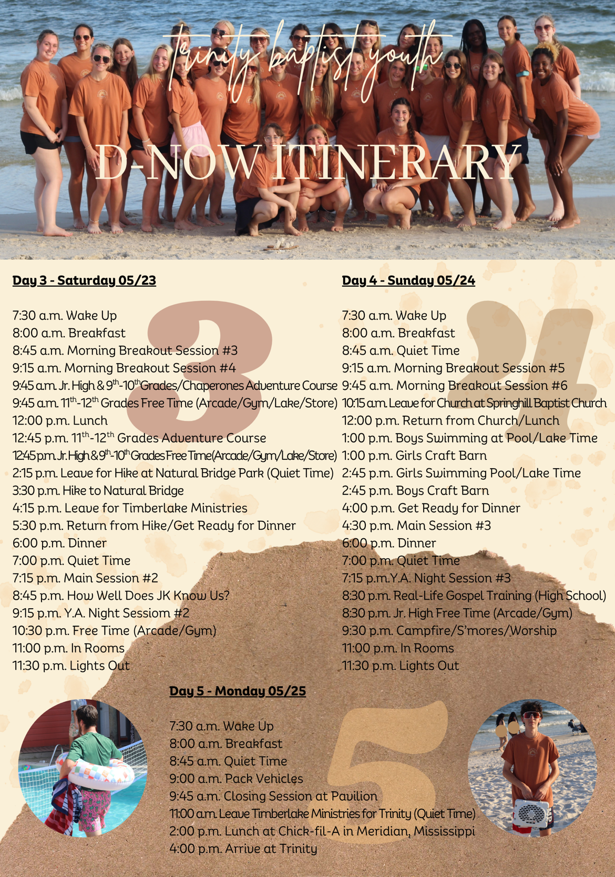

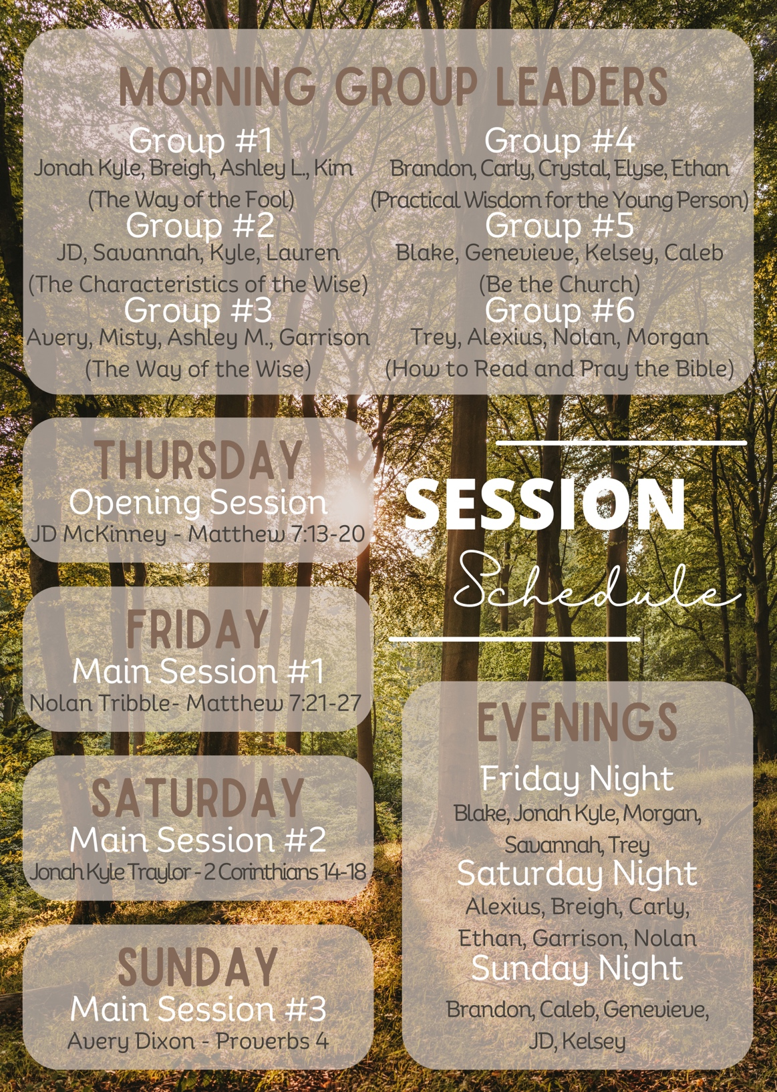


Theme Memory Verse:

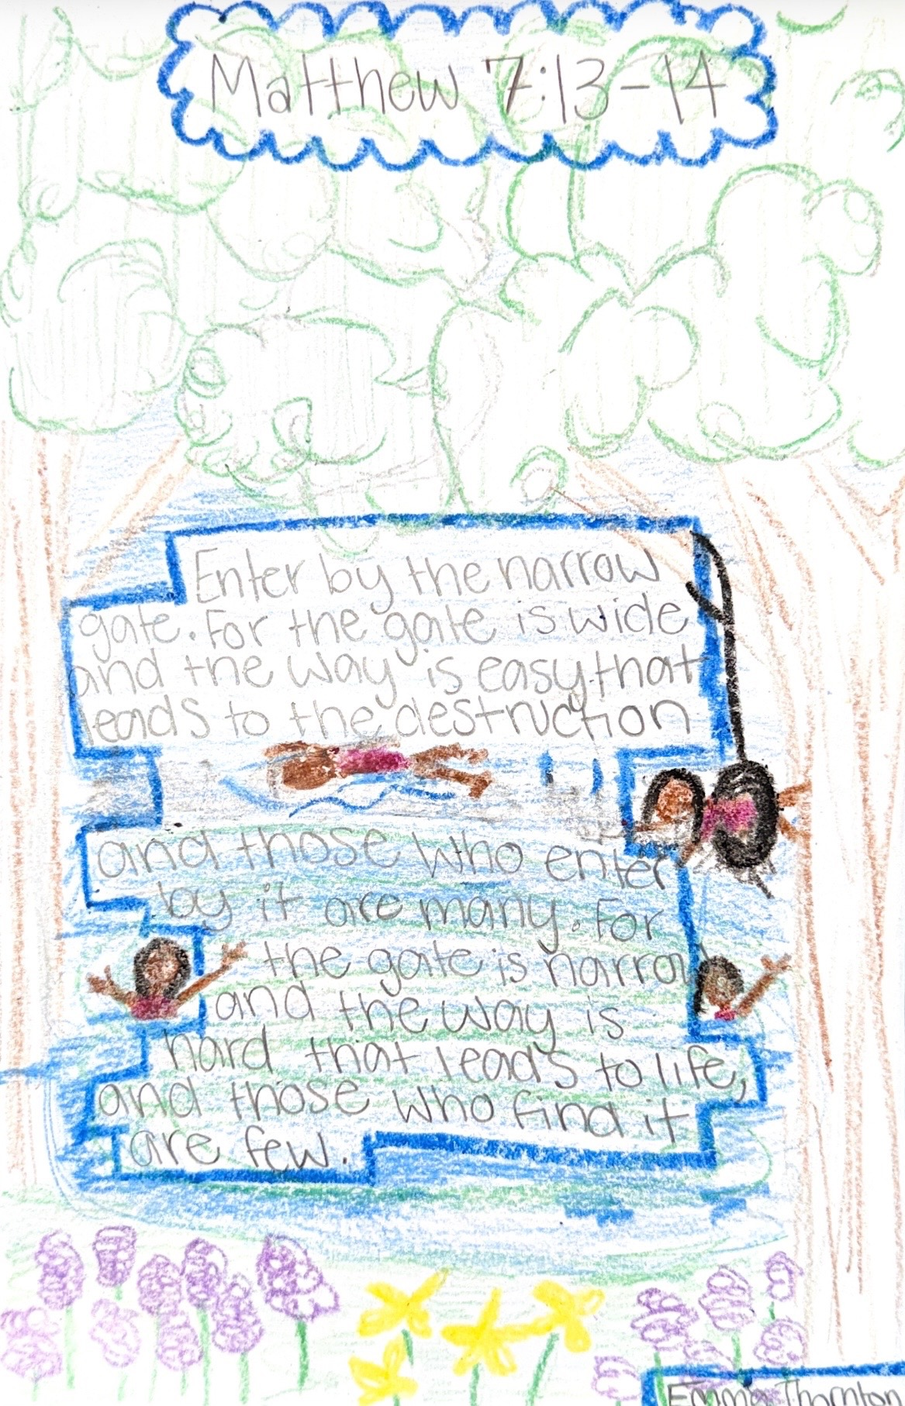
Thursday Memory Verse

Thursday AM Devo:

Proverbs‬ 28‬:26 “Whoever trusts in his own mind is a fool, but he who walks in wisdom will be delivered.”‬‬

By Faith:

In the book of Proverbs, we see many sayings that encourage us to become wise. These verses also show us what foolishness looks like by comparing it to wise living. Today’s passage is one of those comparisons—it shows the difference between foolish self-reliance and walking in wisdom.
There is a good kind of self-reliance. This is when we honestly recognize the abilities God has given us and use them so we don’t become a burden to others. This kind of self-reliance actually reflects faith, because it honors God when we put His gifts to good use. It helps us live productively and set a good example for others (1 Thess. 4:10–12). This healthy self-reliance comes from knowing ourselves accurately. It doesn’t ignore humility. It keeps us depending on God, open to His correction, and willing to learn from others (“Give instruction to a wise man, and he will be still wiser; teach a righteous man, and he will increase in learning.” - Proverbs‬ 9‬:9‬).‬‬‬
But there is also a foolish kind of self-reliance. This is when a person treats their own thoughts and opinions as the final authority. In a sense, it puts self on the throne. This attitude does not show a teachable heart. Instead, it shows misplaced confidence—trusting too much in one’s own ideas. The fool ignores the message of Proverbs, which says that wise people seek instruction and care about their own spiritual growth (Prov. 15:32; 19:8). This kind of foolishness is sinful because it refuses to learn God’s ways even when they are right in front of us (Isa. 26:9–10).
The Bible commentator Matthew Henry describes a fool this way:
A fool trusts his own heart—his own wisdom, his own strength, his own goodness, and the high opinion he has of himself. But this is foolish, because the human heart is deceitful (Jer. 17:9) and has misled him many times.
If trusting in your own mind above everything else makes you foolish, then wisdom means the opposite: rejecting self-trust and choosing to trust the Lord instead. Walking in wisdom (Prov. 28:26) means submitting our ideas, our opinions, and our decisions to what God says. When we do this, God directs our steps and gives us guidance (Prov. 3:5–6).
Through wisdom, we are also rescued from temptation because we look for the way out God promises to give us (1 Cor. 10:13). And ultimately, we receive deliverance from death itself, because trusting in the Lord gives us eternal life (John 3:16).

Attributes of a Wise Person

Wisdom isn’t just something you have — it’s something you live out. Here are the biblical traits of someone who walks in God’s wisdom:

1. The Wise Listen and Learn
“Let the wise listen and add to their learning.” — Proverbs 1:5
A wise person is teachable. They don’t pretend to know everything. They listen to God, leaders, and truth—even when it challenges them.
2. The Wise Respect the Lord
“The fear of the Lord is the beginning of knowledge.” — Proverbs 1:7
Their decisions show that they honor God above everything else. His voice matters most.
3. The Wise Choose Their Friends Carefully
“Walk with the wise and become wise…” — Proverbs 13:20
They surround themselves with people who build them up and push them toward God.
4. The Wise Use Their Words to Heal
“The tongue of the wise brings healing.” — Proverbs 12:18
Their words bring peace, encouragement, and truth — not drama, gossip, or tearing people down.
5. The Wise Think Before They Act
“The prudent give thought to their steps.” — Proverbs 14:15
They pause before reacting. They ask, “Will this honor God? Will this help or harm?”-
6. The Wise Accept Correction
“Whoever loves discipline loves knowledge.” — Proverbs 12:1
A wise person doesn’t get angry when corrected — they grow from it.

What did you learn and how can you apply it?

Thursday Main Session Notes
“The Narrow Gate” - JD

Matthew 7:13–14 (ESV) — 13 “Enter by the narrow gate. For the gate is wide and the way is easy that leads to destruction, and those who enter by it are many. 14 For the gate is narrow and the way is hard that leads to life, and those who find it are few.

Notes:

Thursday PM Devo:

4 I therefore, a prisoner for the Lord, urge you to walk in a manner worthy of the calling to which you have been called, 2 with all humility and gentleness, with patience, bearing with one another in love, 3 eager to maintain the unity of the Spirit in the bond of peace. 4 There is one body and one Spirit—just as you were called to the one hope that belongs to your call— Ephesians 4:1-4

By Misty:

The Way of the Wise-Unity

Unity sounds simple until you’re around people who think differently than you, annoy you, misunderstand you, wrong you, or seem impossible to connect with. Real unity isn’t everyone being the same or everyone being perfect. It’s people choosing to love, forgive, encourage, and pursue Jesus together despite differences.

The church was never meant to be built on sameness or perfection. God created different personalities, gifts, backgrounds, and stories. Unity doesn’t erase differences, but it does bring them together for a bigger purpose.

Think about a body: hands, eyes, feet, and ears all have different jobs. Imagine if one part decided it didn’t need the others. The whole body would struggle. In the same way, God designed His people to need one another.

Francis Chan writes, “Once we stop worshipping, all hope for unity is lost.” That sounds surprising at first but think about it: when our attention shifts from Jesus to ourselves (our preferences, opinions, hurts, and pride) division grows. But when our eyes are fixed on Christ, worship changes our posture. Humility and grace grow and unity becomes possible.

Our world often pushes division (pick sides, cancel people, stay with those who agree with you). Jesus calls us to something different. He calls us to humility, patience, forgiveness, and peace.

Unity requires effort. It means listening before reacting. Choosing grace instead of offense. Encouraging instead of criticizing. Remembering that other believers aren’t competitors. They are family! The strongest witness to the world may not be how loudly Christians speak, but how deeply we love one another.

Reflect:

- Is there someone I’ve allowed hurt, pride, or annoyance to create distance with?
- Am I helping build unity in my friendships, church, and family or contributing to division?
- What would it look like for me to actively pursue peace this week?

Prayer:

God, thank You for creating us with different gifts and personalities. Teach me to value others the way You do. Help me choose humility over pride, grace over offense, and peace over division. Make me someone who builds unity wherever I go and asks for forgiveness when I don’t. Help our church and our community reflect Your love through the way we care for one another. Amen.

Challenge:

This week, intentionally encourage someone, include someone, or repair a relationship that has become strained. Unity grows through small acts of love and humility.

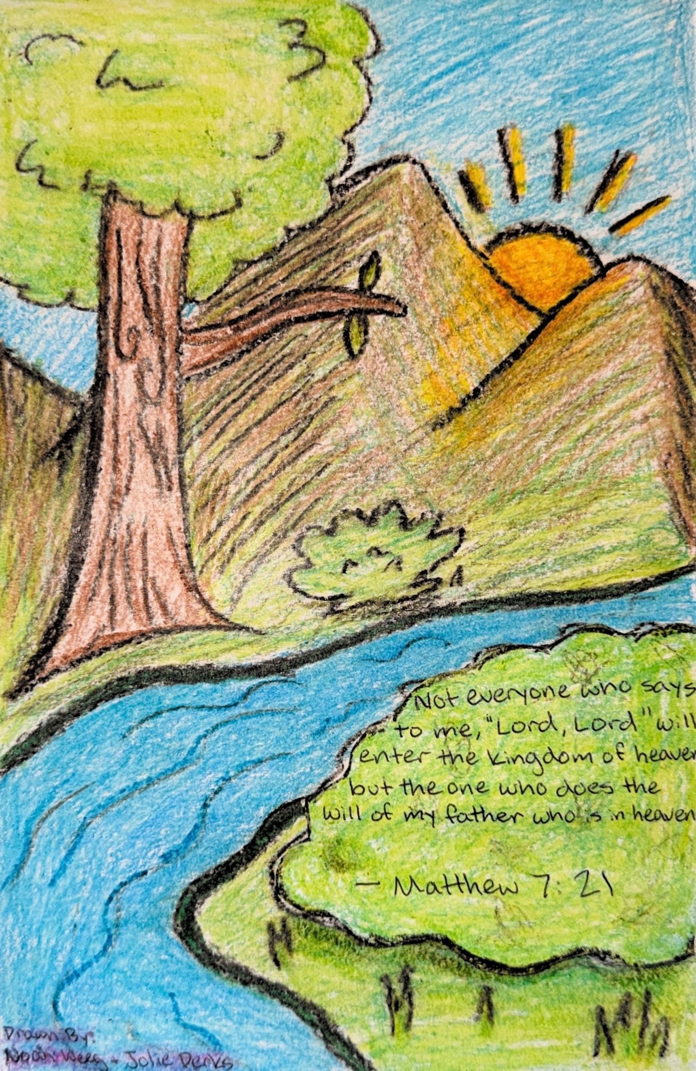
Friday Memory Verse

Friday Am Devo

Psalm 1 – “1Blessed is the man who walks not in the counsel of the wicked, nor stands in the way of sinners, nor sits in the seat of scoffers; 2 but his delight is in the law of the Lord, and on his law he meditates day and night. 3 He is like a tree planted by streams of water that yields its fruit in its season, and its leaf does not wither. In all that he does, he prospers. 4 The wicked are not so, but are like chaff that the wind drives away. 5 Therefore the wicked will not stand in the judgment, nor sinners in the congregation of the righteous; 6 for the Lord knows the way of the righteous, but the way of the wicked will perish.”

By Blake

The world we live in is constantly trying to pull us into sin and away from God. Whether it be our phone, sports, or even people, the things of this world will ultimately lead us to a path of destruction. That is, if we put those things in front of the One who saved us from it, Jesus. Psalm 1 gives a great representation of what it looks like to stray from this world and put the Lord first. By delighting in His Law and meditating on it day and night. Jesus says in John 15:4, “Abide in me, and I in you. As the branch cannot bear fruit by itself, unless it abides in the vine, neither can you, unless you abide in me.” The Greek word “abide” is translated from, also means to live/reside. How are we to live in Jesus? By listening to what He provided us, His eternal Word. We are called to have a relationship with Him, listen to Him by reading his Word and delighting in it because it brings life!
In doing this, the psalmist says we are like trees planting ourselves by water, enabling us to “yield fruit”. Now, what does it mean to “yield fruit”? Just as a tree produces fruit for others’ benefit, we produce works for God and others. By staying in God’s Word and storing it in our heart (Psalm 119:11), we are equipped for every good work (2 Timothy 3:16-17) to advance God’s Kingdom. We are ensured that we prosper, not necessarily for ourselves, but succeed in bringing benefit to others.
Psalm 1 also emphasizes the difference between the righteous and the wicked. The wicked, people who live in accordance to the world and their own sinful desires, will perish. The righteous, those who trust in Jesus Christ and actively pursue Him daily, will prosper and produce fruit. The psalmist says, “for the Lord knows the way of the righteous”. We have a God that truly knows us and is jealous for us! He showed us this by sending His one and only Son to die on a cross and pay for our sins, so we can have a relationship with Him. We should turn from the ways of this world and look to Jesus, pursue Him, and live out His Law joyfully!

Reflection Questions:

· What are some things that are pulling me away from God or I’m idolizing?
· How consistent am I in reading and meditating on God’s Word?
· When I read the Bible, do I delight in it or feel like I’m doing a chore? Why?
· What is one change I can make this week to pursue Jesus more intentionally?

Breakout Session 1: The Way of the Fool
(Jonah Kyle, Breigh, Ashley L, Kim)

Psalm 14:1 (ESV) — 1 The fool says in his heart, “There is no God.” They are corrupt, they do abominable deeds; there is none who does good.
Proverbs 10:1 (ESV) — 1 The proverbs of Solomon. A wise son makes a glad father, but a foolish son is a sorrow to his mother.
1 Samuel 2:12 (ESV) — 12 Now the sons of Eli were worthless men. They did not know the Lord.

Notes:

Breakout Session 2: Characteristics of the Wise
(JD, Savannah, Kyle, Lauren)

Proverbs 8:14–15 (ESV) — 14 I have counsel and sound wisdom; I have insight; I have strength. 15 By me kings reign, and rulers decree what is just;
Psalm 112:1 (ESV) — 1 Praise the Lord! Blessed is the man who fears the Lord, who greatly delights in his commandments!
Job 28:28 (ESV) — 28 And he said to man, ‘Behold, the fear of the Lord, that is wisdom, and to turn away from evil is understanding.’ ”
Proverbs 3:11–12 (ESV) — 11 My son, do not despise the Lord’s discipline or be weary of his reproof, 12 for the Lord reproves him whom he loves, as a father the son in whom he delights.
Proverbs 27:12 (ESV) — 12 The prudent sees danger and hides himself, but the simple go on and suffer for it.

Notes:

Breakout Session 3: The Way of the Wise
(Avery, Misty, Ashley M, Garrison)

Proverbs 4:7–8 (ESV) — 7 The beginning of wisdom is this: Get wisdom, and whatever you get, get insight. 8 Prize her highly, and she will exalt you; she will honor you if you embrace her.
Proverbs 9:10 (ESV) — 10 The fear of the Lord is the beginning of wisdom, and the knowledge of the Holy One is insight.
Luke 5:8 (ESV) — 8 But when Simon Peter saw it, he fell down at Jesus’ knees, saying, “Depart from me, for I am a sinful man, O Lord.”
Jeremiah 10:6–7 (ESV) — 6 There is none like you, O Lord; you are great, and your name is great in might. 7 Who would not fear you, O King of the nations? For this is your due; for among all the wise ones of the nations and in all their kingdoms there is none like you.
Psalm 147:11 (ESV) — 11 but the Lord takes pleasure in those who fear him, in those who hope in his steadfast love.

Notes:

Breakout Session 4: Practical Advice for the Young Person
(Brandon, Carley, Crystal, Elyse, Ethan)

2 Corinthians 5:17 (ESV) — 17 Therefore, if anyone is in Christ, he is a new creation. The old has passed away; behold, the new has come.
Psalm 139:13–14 (ESV) — 13 For you formed my inward parts; you knitted me together in my mother’s womb. 14 I praise you, for I am fearfully and wonderfully made. Wonderful are your works; my soul knows it very well.
1 Corinthians 15:33–34 (ESV) — 33 Do not be deceived: “Bad company ruins good morals.” 34 Wake up from your drunken stupor, as is right, and do not go on sinning. For some have no knowledge of God. I say this to your shame.
2 Corinthians 6:14 (ESV) — 14 Do not be unequally yoked with unbelievers. For what partnership has righteousness with lawlessness? Or what fellowship has light with darkness?
1 Peter 4:10–11 (ESV) — 10 As each has received a gift, use it to serve one another, as good stewards of God’s varied grace: 11 whoever speaks, as one who speaks oracles of God; whoever serves, as one who serves by the strength that God supplies—in order that in everything God may be glorified through Jesus Christ. To him belong glory and dominion forever and ever. Amen.

Notes:

Breakout Session 5: Be The Church
(Blake, Genevieve, Kelsey, Caleb)

Hebrews 10:24–25 (ESV) — 24 And let us consider how to stir up one another to love and good works, 25 not neglecting to meet together, as is the habit of some, but encouraging one another, and all the more as you see the Day drawing near.

Romans 12:4–5 (ESV) — 4 For as in one body we have many members, and the members do not all have the same function, 5 so we, though many, are one body in Christ, and individually members one of another.

Colossians 3:15–16 (ESV) — 15 And let the peace of Christ rule in your hearts, to which indeed you were called in one body. And be thankful. 16 Let the word of Christ dwell in you richly, teaching and admonishing one another in all wisdom, singing psalms and hymns and spiritual songs, with thankfulness in your hearts to God.

Notes:

Breakout Session 6: How to Read and Pray the Bible
(Trey, Alexius, Nolan, Morgan)

2 Timothy 2:15 (ESV) — 15 Do your best to present yourself to God as one approved, a worker who has no need to be ashamed, rightly handling the word of truth.
Matthew 6:9–13 (KJV 1900) — 9 After this manner therefore pray ye: Our Father which art in heaven, Hallowed be thy name. 10 Thy kingdom come. Thy will be done in earth, as it is in heaven. 11 Give us this day our daily bread. 12 And forgive us our debts, as we forgive our debtors. 13 And lead us not into temptation, but deliver us from evil: For thine is the kingdom, and the power, and the glory, for ever. Amen.

Notes:

Friday Main Session Notes
“The Wise and Foolish Builders” - Nolan

Matthew 7:24–27 (ESV) — 24 “Everyone then who hears these words of mine and does them will be like a wise man who built his house on the rock. 25 And the rain fell, and the floods came, and the winds blew and beat on that house, but it did not fall, because it had been founded on the rock. 26 And everyone who hears these words of mine and does not do them will be like a foolish man who built his house on the sand. 27 And the rain fell, and the floods came, and the winds blew and beat against that house, and it fell, and great was the fall of it.”

Friday Pm Breakout Session
(Blake, Jonah, Morgan, Savannah, Trey)

Notes:

Friday Pm Devo

John 12:1-3 Six days before the Passover, Jesus therefore came to Bethany, where Lazarus was, whom Jesus had raised from the dead. 2 So they gave a dinner for him there. Martha served, and Lazarus was one of those reclining with him at table. 3 Mary therefore took a pound of expensive ointment made from pure nard, and anointed the feet of Jesus and wiped his feet with her hair. The house was filled with the fragrance of the perfume.
Mark 14:9 And truly, I say to you, wherever the gospel is proclaimed in the whole world, what she has done will be told in memory of her.”

By JD: What makes a life worth remembering?

There is only one time in Scripture that Jesus says something like this. Only one person whose life He declares should never, ever be forgotten. And it's not a king, not a conqueror, not a scholar. It's Mary of Bethany. A woman whose love, devotion, sacrifice, and understanding are so worthy of attention that the King of creation says, wherever the gospel is preached—every corner of the globe—don't forget the life of Mary of Bethany.

That's quite a statement.

So what made Mary's life worth remembering? Four things stand out: First, her sacrifice. She takes a pound of expensive ointment/oil—worth a year's wages, thousands of dollars—and pours it out at the feet of Jesus. Every single drop is worth hundreds of dollars. This may have been a family heirloom, her life savings, or an investment. And in a matter of seconds, it's gone. Poured out at the feet of Jesus. Is there anything too extravagant in your life that you wouldn’t bring to the feet of Jesus?
Mary doesn't drip only a drop of what she has. She's not sharing with Jesus. She's surrendering everything she has, sacrificing everything she has for Him. David said in 2 Samuel 24:24, "I will not offer burnt offerings to the LORD my God that cost me nothing.”

It's not a sacrifice if it costs you nothing.

Second, her humility. In 1 Corinthians 11, culturally speaking, the glory of a woman was her hair. And yet Mary takes her glory and turns it into a rag at the feet of Jesus. She wipes His feet with her hair. Washing feet was the work of a slave—too low even for the lowest disciple, but Mary takes the form of a servant. Ironically, it is the lowest acts of service in Scripture that God magnifies the most.
Third, her insight. Jesus says in verse 7, "Leave her alone, so that she may keep it for the day of my burial." Mary knew Jesus was going to die, and this was her gift to Him. How did she know? She knew because of where we so often find her—at the feet of Jesus, listening attentively.
Fourth, her love. Mary is overflowing with love for her Savior. John Piper says, "It's a beautiful thing when the worth of Jesus and the love of His followers match."
And what's the effect of her love and sacrifice? Verse 3 says, "the house was filled with the fragrance of the perfume." Every act of private worship ends up affecting more people than you would ever anticipate. You live your life entirely for God's glory, and your life becomes an aroma, a blessing to the world around you.
What you do for a living may seem routine. Going to school, being an athlete, or working at 7 Brew may make it hard to see how your life can be pleasing to the Lord. But as we see in the life of Mary, if you're serving the Lord, if you're walking in humility, if you're loving the Lord God with all your heart, soul, mind, and strength—your life will be worth remembering in the mind of God.

Reflection Questions:
1. What are you holding back from Jesus that He's asking you to pour out at His feet?
2. Are you more concerned with what people think of you or what God thinks of you?
3. Where do you spend your time—at the feet of Jesus listening, or distracted by a hundred other things?

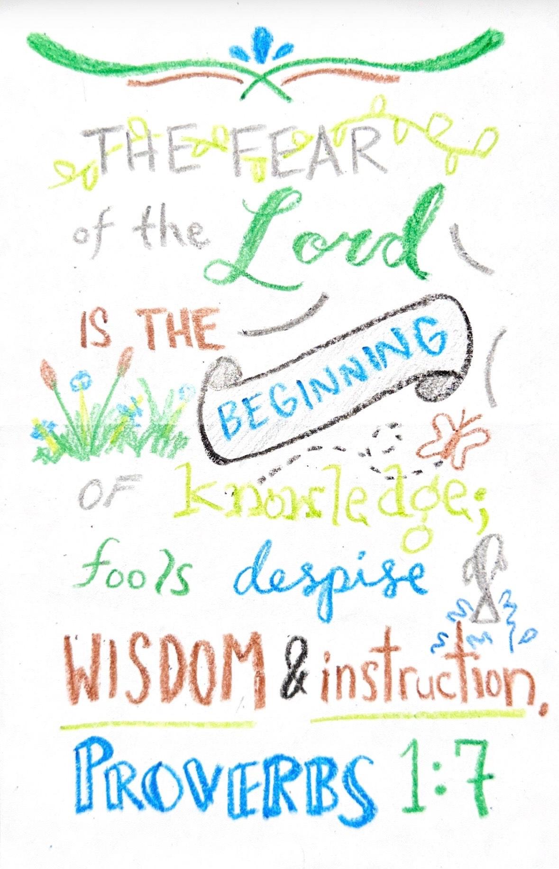
Saturday Memory Verse

Saturday Am Devo

Colossians 1:9-10 (ESV) - ⁹ And so, from the day we heard, we have not ceased to pray for you, asking that you may be filled with the knowledge of his will in all spiritual wisdom and understanding, ¹⁰ so as to walk in a manner worthy of the Lord, fully pleasing to him: bearing fruit in every good work and increasing in the knowledge of God;

By Brandon:

​When Paul wrote his letter to the church in Colossus, he wanted to address some of the cultural pushbacks Christians were getting. At the time, those pushbacks led those Christians to believe that Jesus was less than God and that they needed a secret higher knowledge to be saved. Paul wrote this letter to affirm the Colossians that Jesus is enough for their salvation, and that they don’t need a secret higher knowledge for salvation. They only need the knowledge, spiritual wisdom, and understanding of God.
​We see here that Paul is making an effort to pray for the people in the church of Colossus. He prays that they be filled with the “knowledge of his will in all spiritual wisdom and understanding.” Since Paul is praying this, it means that knowledge, spiritual wisdom, and understanding are all attributes that Christians need to have. But why do we need these attributes? Paul says that Christians need these qualities so that they can “walk in a manner worthy of the Lord, fully pleasing to him: bearing fruit in every good work and increasing in the knowledge of God.” Thus, we have a connection: Christians that have knowledge, spiritual wisdom, and understanding in God, live their lives in a way that is worthy in His eyes.
​So, how can we train in our knowledge, spiritual wisdom, and understanding in God? The best way to train our knowledge of God is to read His Word. 2 Timothy 3:16-17 (ESV) says “All scripture is breathed out by God and profitable for teaching, for reproof, for correction, and for training in righteousness, that the man of God may be complete, equipped for every good work” By reading the word of God we are “training ourselves for righteousness.” We are learning more about what God says is right and wrong in His eyes. Thus, we equip ourselves for “every good work” and can live our lives worthy of the Lord.
​To grow in our spiritual wisdom, we first need to understand what spiritual wisdom is. James 3:17 (ESV) says “But the wisdom from above is first pure, then peaceable, gentle, open to reason, full of mercy and good fruits, impartial and sincere.” This sounds a lot like the Fruit of the Spirit from Galatians 5:22-23. Notice that these are all attributes that Christians grow in. In order to train in our spiritual wisdom, we first need the Holy Spirit in our hearts, and then we need to put into practice what we learn from God’s Word. By applying our knowledge of God into our everyday lives, we grow in our spiritual wisdom. It’s like a graduating college student. In order for them to grow in their wisdom, they need to apply what they learned in school to their everyday life.
​In the end, knowledge, spiritual wisdom, and understanding are all attributes that Christians need to exhibit. They bring us closer to God, and when we practice these attributes faithfully, they are pleasing to God. It may take time to grow in these areas, but they are extremely important if we want to grow in our relationship with God.

Reflection Question:
How can you spend time this week to grow in your knowledge, spiritual wisdom, and understanding in God?

Saturday Main Session
“The Fellowship of the Wise” – J.K.

2 Corinthians 6:14–18 (ESV) — 14 Do not be unequally yoked with unbelievers. For what partnership has righteousness with lawlessness? Or what fellowship has light with darkness? 15 What accord has Christ with Belial? Or what portion does a believer share with an unbeliever? 16 What agreement has the temple of God with idols? For we are the temple of the living God; as God said, “I will make my dwelling among them and walk among them, and I will be their God, and they shall be my people. 17 Therefore go out from their midst, and be separate from them, says the Lord, and touch no unclean thing; then I will welcome you, 18 and I will be a father to you, and you shall be sons and daughters to me, says the Lord Almighty.”

Notes:

Saturday Pm Breakout Session
(Alexius, Breigh, Carley, Ethan, Garrison, Nolan)

Notes:

Saturday Pm Devo

Habakkuk 1:2–4 (ESV) — 2 O Lord, how long shall I cry for help, and you will not hear? Or cry to you “Violence!” and you will not save? 3 Why do you make me see iniquity, and why do you idly look at wrong? Destruction and violence are before me; strife and contention arise. 4 So the law is paralyzed, and justice never goes forth. For the wicked surround the righteous; so justice goes forth perverted.

By Matt and Julie:

Have you read the book of Habakkuk? He was a prophet in the final years of Judah before they went into Babylonian captivity. Habakkuk is burdened by the spiritual darkness in Judah as he watches God’s people live in sin without consequence. Habakkuk questions God and asks if God even hears him as he cries out for justice. God answers by declaring that He will judge Judah through Babylon, a nation even more wicked and rebellious than they are. Then Habakkuk cries out to God again, struggling to understand how He could use a nation more wicked than Judah to discipline His own covenant people. In Habakkuk 1:13 he asks, “Why are you silent while one who is wicked swallows up one who is more righteous than himself?” God responds by assuring Habakkuk that Babylon will not escape judgment. Though He will use them as an instrument of discipline, He will also punish them for their own sin, pronouncing five woes against them.
Habakkuk responds by pleading with God to remember mercy in the midst of His wrath. Chapter 3 highlights both the justice and holiness of God as well as His power over the nations. Habakkuk comes to a proper fear and understanding of God’s righteous judgment against sin, yet he also clings to the truth that God is merciful. As judgement approaches for Judah and Babylon, Habakkuk moves from asking for justice to humbly asking for mercy. The book closes with a powerful expression of faith and hope, encouraging the reader to trust in God even in the midst of suffering and uncertainty.
“Though the fig tree does not bud and there is no fruit on the vines, though the olive crop fails and the fields produce no food, the flocks disappear from the pen and there are no herds in the stalls, yet I will celebrate in the LORD; I will rejoice in the God of my salvation!” Hab.3:17-18
At times, believers can lose hope as we look at the darkness of the world around us and see so many people rejecting God and refusing to trust in Christ for salvation. We know the coming judgment that awaits unrepentant sinners—eternal separation from a holy and loving God. Yet Habakkuk reminds us that even in a dark world, we are called to walk by faith (Habakkuk 2:4) and cry out to God for mercy on those who do not believe. We should ask God to give us opportunities to point unbelievers to the hope we have in Christ.
Habakkuk ultimately reminds us where our strength is found: “The LORD my Lord is my strength; he makes my feet like those of a deer and enables me to walk on mountain heights!” (Habakkuk 3:17–19). Though the world around us may seem hopeless, God gives His people strength to stand firm and walk faithfully.
When you look at the unbelieving world around you, does it move you to cry out to God for mercy on those who are lost? If not, ask God to give you a burden for the people around you, to make you a light in the darkness, and to open doors for you to point others to the saving hope found in Jesus Christ.

What did you learn and how do you apply it?

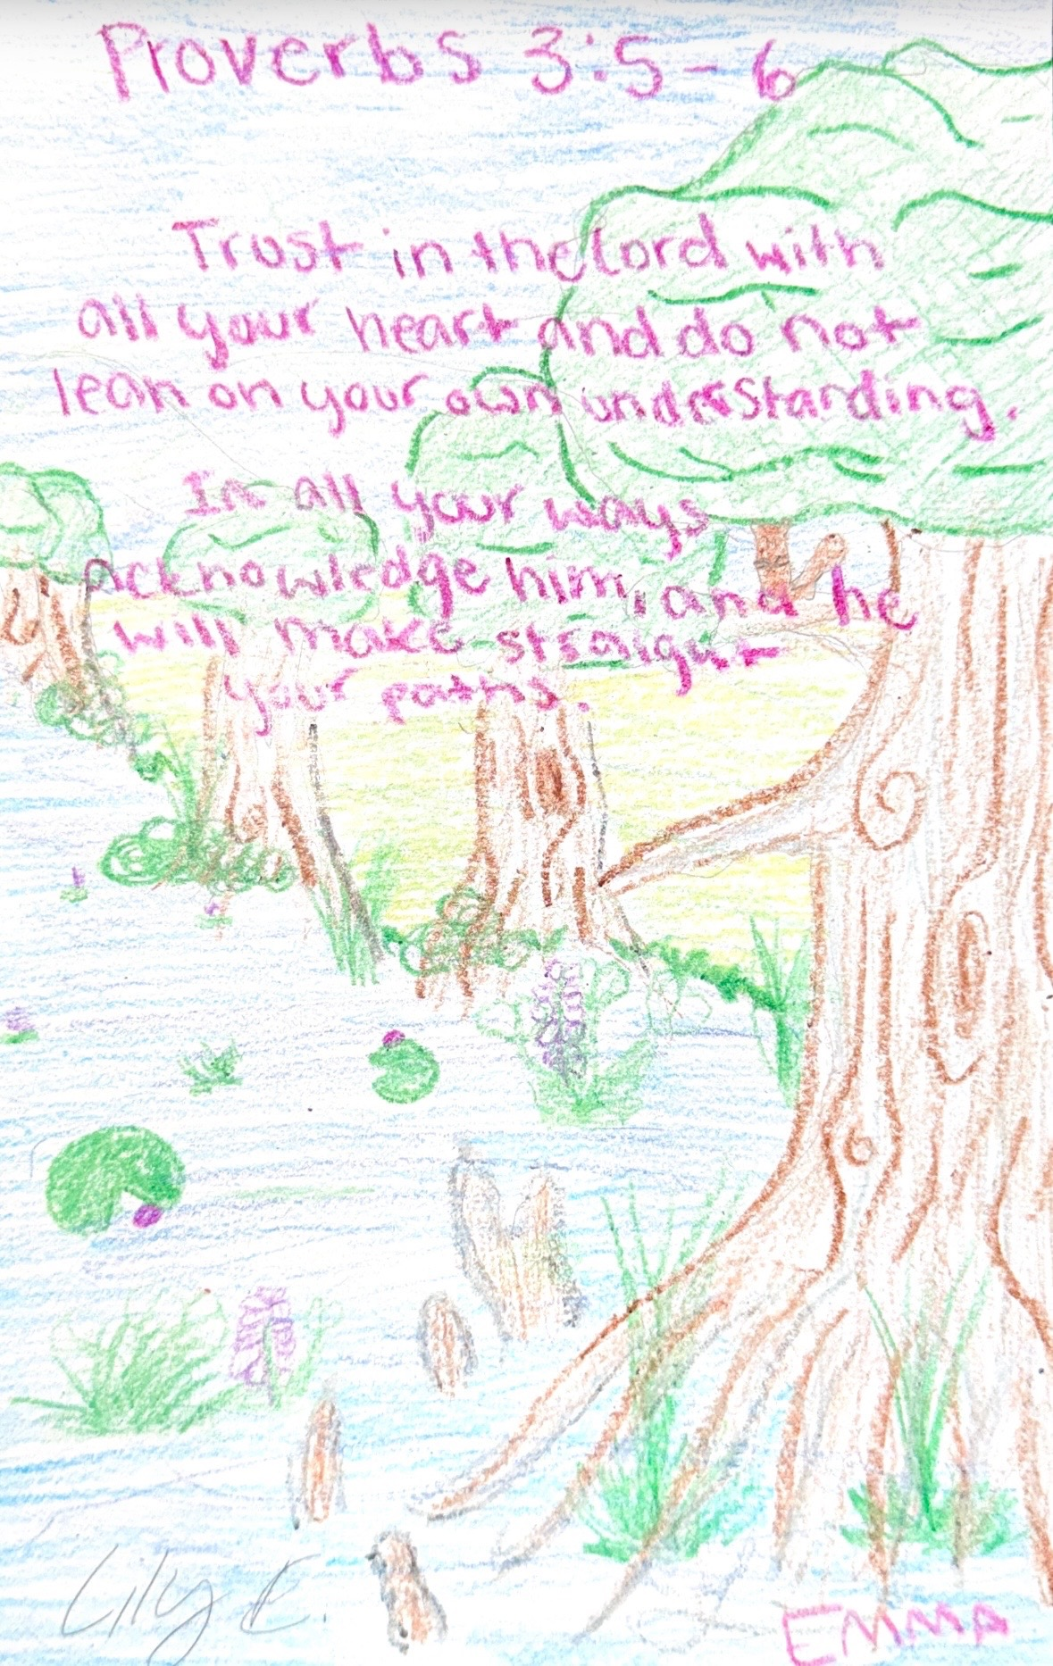
Sunday Memory Verse

Sunday Am Devo

Psalm 73:24 "You will guide me with thy counsel and afterward receive me to glory."

By Charles Spurgeon:

The psalmist felt his need of divine guidance. He had just been discovering the foolishness of his own heart, and to prevent himself from being constantly led astray by it, he resolved that God’s counsel should be his guide. A sense of our own folly is a great step toward being wise, when it leads us to rely on the wisdom of the Lord. The blind man leans on his friend’s arm and reaches his home in safety, and likewise we should give ourselves up implicitly to divine guidance, without doubting, assured that even though we cannot see, it is always safe to trust the All-seeing God. “You will” is a blessed expression of confidence. He was sure that the Lord would not neglect the necessary task.

Here is a word for you, believer; rest in it. Be sure that God will be your counselor and friend; He will guide you; He will direct all your ways. In His written Word you have this assurance fulfilled in part, for Holy Scripture is His “counsel” to you. We are happy to have God’s Word as our constant guide! What is the sailor without his compass? And what is the Christian without the Bible? This is the unerring chart, the map in which every shoal is described, and all the channels from the quicksands of destruction to the harbor of salvation mapped and marked by one who knows the way.

O God we bless You, that we may trust You to guide us now, and even to the end! After this guidance through life, the psalmist anticipates a divine reception—“and afterward . . . receive me to glory.” What a thought for you, believer! God Himself will receive you in glory—you! Though you are wandering, erring, straying, still He will bring you safe at last to glory! This is your portion; live on it today, and if perplexities should surround you, go in the strength of this text straight to the throne.

What did you learn and how do you apply it?

Sunday Main Session
“A Father’s Wise Words” - Avery

Proverbs 4:1–2 (ESV) — 1 Hear, O sons, a father’s instruction, and be attentive, that you may gain insight, 2 for I give you good precepts; do not forsake my teaching
Proverbs 4:5–9 (ESV) — 5 Get wisdom; get insight; do not forget, and do not turn away from the words of my mouth. 6 Do not forsake her, and she will keep you; love her, and she will guard you. 7 The beginning of wisdom is this: Get wisdom, and whatever you get, get insight. 8 Prize her highly, and she will exalt you; she will honor you if you embrace her. 9 She will place on your head a graceful garland; she will bestow on you a beautiful crown.”
Proverbs 4:26–27 (ESV) — 26 Ponder the path of your feet; then all your ways will be sure. 27 Do not swerve to the right or to the left; turn your foot away from evil.

Notes:

Sunday Pm Breakout Session
(Brandon, Caleb, Genevieve, JD, Kelsey)

Notes:

Sunday Pm Devo

Luke 13:6–9 (ESV) — 6 And he told this parable: “A man had a fig tree planted in his vineyard, and he came seeking fruit on it and found none. 7 And he said to the vinedresser, ‘Look, for three years now I have come seeking fruit on this fig tree, and I find none. Cut it down. Why should it use up the ground?’ 8 And he answered him, ‘Sir, let it alone this year also, until I dig around it and put on manure. 9 Then if it should bear fruit next year, well and good; but if not, you can cut it down.’ ”

This has long been one of the most convicting passages in all of scripture. “Cut it down, why should it use up the ground?” Jesus isn’t talking about a vinedresser and a fig tree here. He is talking about you and your status before God. You are the fig tree. Stop and think about that.
Jesus is using this parable to illustrate to us the importance of being a person that is useful for God’s purposes. The owner of the vineyard is checking out his planted trees. He comes to one, a fig tree, and notices that it isn’t bearing any fruit. In fact, it has been three years he has come to find fruit and there is still none. Then he says something that may sound shocking, but it in reality is fair. He says,c“cut it down.” Then he asks his hired vinedresser, “Why should it use up the ground?”
By saying these things, the man lets us in on how he thinks. He is a businessman. He has planted these trees to make a profit. The purpose of the tree is that it would bear fruit. If it doesn’t bear fruit, then it has no purpose in his vineyard. The space it took up was probably about 400 sq ft. It took fertilizer and water while also having to be pruned yearly. It was taking up time and resources but giving nothing in return. In the eyes of the owner, it would be better to take that space and plant a new tree there.
Let’s move the parable to Jesus’s intended target. You and Me. Jesus is speaking to people that He has created. This is so very serious. Jesus is telling us, He sees us. He notices who we are and what we are doing with the resources He has given us. All people have been blessed by God with time, energy, giftings, and stuff. But not all people use them to bear good fruit. Often people use these things only for themselves. God has an expectation for us. His expectation is that you will bear fruit in His kingdom. And if you don’t, there is a warning of judgment here. The warning is, “Cut it down. Why should it use up the ground?’” This should really wake us up. We don’t want this spoken over our lives. This should cause us to look at our lives and examine them. We should ask ourselves very wise questions like, “What does God expect from me?” “How Can I serve God with the gifts He has given to me?”
One final thing. You must take ownership of your own life. It is not your parents or friends that will stand before God for you. You must stand there and give an account of your life. Often people just go through the motions in this world never considering their ways or their days. This would be foolish. Be wise and recognize there is a God who is real and He expects you to bear fruit in His name.
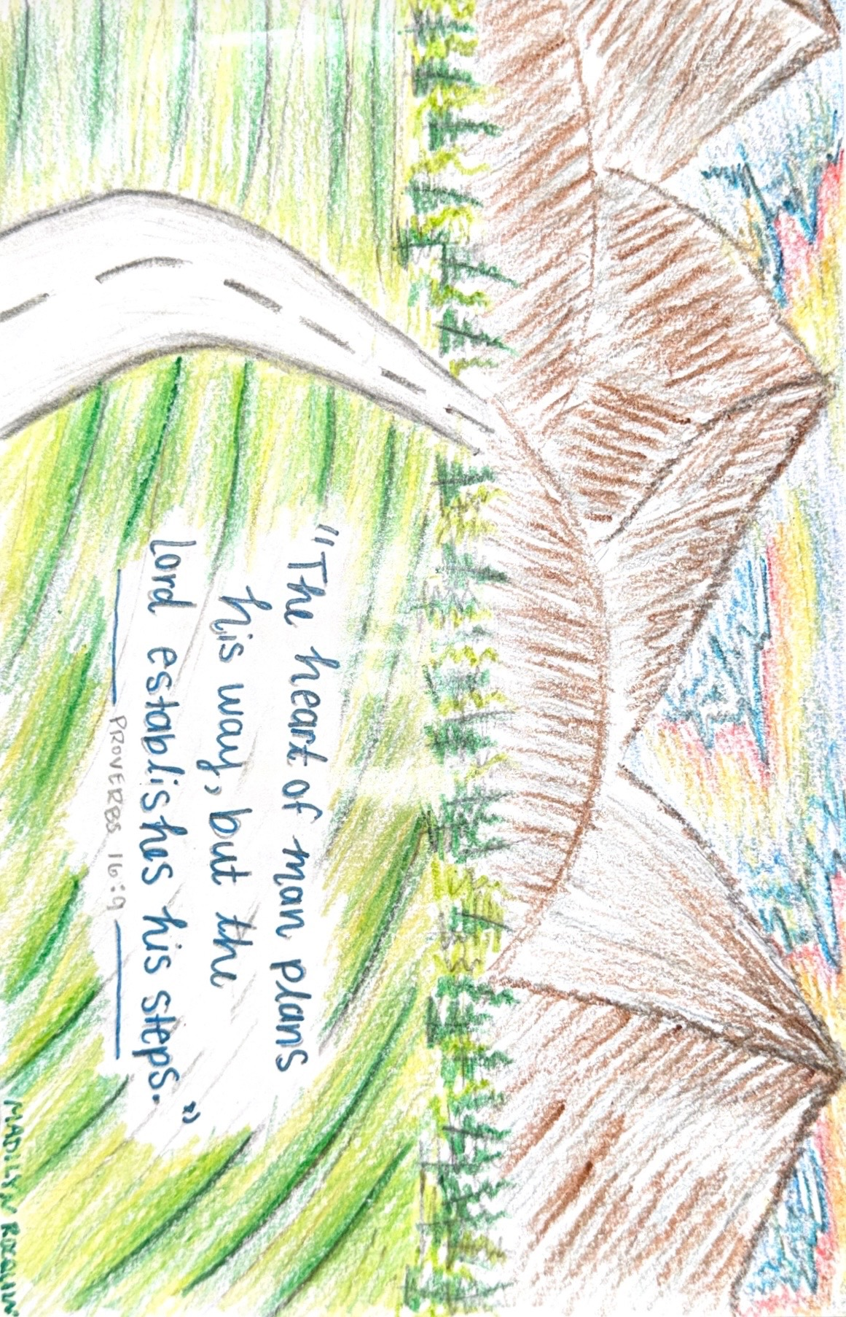
Monday Memory Verse:

Monday Am Devo

Whoever walks with the wise becomes wise, But the companion of fools will suffer harm. Proverbs 13:20

By Jonah:

From the beginning of time, people have risen and fallen from the influence of others. In your lifetime, you will often encounter either those inspired by God to demonstrate wisdom or those guided by the enemy to express foolishness. We must rely on the discernment of the Holy Spirit to determine the difference between the two.
Eve found companionship in a serpent, Solomon allowed pagan women to destroy his morals, and Pilate sought approval from an angry mob. Equally, Esther influenced King Xerxes to save her people from genocide, Daniel’s faithfulness changed King Nebuchadnezzar’s view of God, and the stoning martyrdom of Stephen affected Saul’s testimony to become the great missionary, Paul. Forces of good and evil are both hard at work to influence you and me. Which will you let control your life?
The point is: Our surroundings affect us in greater ways than we often realize. This is why it’s crucial to be proactive with what you allow to enter your life, and I’m not just talking about people alone. The social media influencers you follow (who only care for their own interest), the music you listen to, the tv shows you watch, the things you read, and even your daily routine can lead you towards God or down a path of destruction before you even realize you’re on it.
Did you know that if you put a frog in a pot of boiling water, it will immediately jump out? That seems pretty obvious, but did you also know that if you put the same frog in a pot of room temperature water, then slowly heat it to a boil, the frog will stay in the pot until it’s boiled alive? Sin is crouching at the door waiting to strike, and those attacks are not usually obvious, but instead small, consistent jabs until you’re being boiled alive.
So if the wise only walk with the wise, how does the fool ever receive a wise influence? Well, there is a way to influence a fool without ‘walking’ with them. I’ve always used the 50/50 analogy with this topic. 50% of the people you surround yourself with should be those who shape you (fellow
Christ-following friends, family, mentors, etc.), and 50% of the people you invest your time in should be those who need to be molded by a Godly influence like you (nonbelieving friends and family, worldly people).
In an ideal scenario, this would mean an even balance of being discipled by the wise while simultaneously being an example to the fools. However, the most important part of this method is self-awareness. Maybe you haven’t been doing as well on your walk with God – then tip the scales to have 75% of your surrounding influences be wise, Godly people who will get you back on track. On the flip side, somebody such as a missionary who is very strong in their faith might could be around 75% foolish unbelievers while still staying on track with God. Either way, every single believer must walk with the wise to become wise – and every single believer is called to share the gospel with the fool.
And yes, while having Godly influences and role models can completely change the way you tackle your faith, what better example of wisdom do we have than Christ Himself? Even the most disciplined and devout followers of Christ have failed, but when we look to Jesus, we look to a foolproof example of The Way of the Wise.
“What’s the best way to handle _____ ?” Well… What would Jesus do? Not every detail of every struggle you face in modern times is perfectly explained in scripture, but God’s Word is living and active, and reading it consistently will give you immense wisdom.

What did you learn and how do you apply it?

Monday Pm Devo

“The fool says in his heart, ‘There is no God’” (Psalms 14:1)

By Faith: The Life of the Fool

Scripture gives a clear and serious picture of what it means to live as a fool—not someone lacking intelligence, but someone who rejects God’s guidance. Foolishness is a heart posture that pushes aside God’s truth in favor of personal independence. “The fool says in his heart, ‘There is no God’” (Psalms 14:1). This does not always sound like open denial; many simply live as if God has no authority over their decisions. The fool acts on self-confidence, not realizing this path leads to spiritual and practical ruin.
The Proverbs describe the life of the fool beginning with a heart that trusts only itself. “The way of a fool is right in his own eyes” (Proverbs 12:15). The fool refuses counsel, resists correction, and believes every opinion they form is unquestionable. Pride becomes their guide, closing their ears to any wisdom that could protect them.
This inner pride quickly shows up in their words. “A fool…only wants to express his opinion” (Proverbs 18:2). They speak before listening, argue before understanding, and let careless words damage others. Their tongue reveals a deeper problem: a stubborn refusal to learn or slow down long enough to gain wisdom.
Another sign of foolish living is the way sin is treated lightly. “Fools mock at sin” (Proverbs 14:9). Instead of seeing sin as harmful, they laugh at it, ignore God’s boundaries, and minimize consequences. What begins as a small disregard for holiness grows into a hardened heart and a life moving toward destruction.
Yet even in these warnings, wisdom quietly stands in contrast. Where the fool depends on himself, the wise trust the Lord. Where the fool speaks recklessly, the wise choose restraint. Where the fool mocks sin, the wise turn away from it. Wisdom may not be the main focus of these verses, but it shines through as the better path.
The life of the fool is loud, proud, and resistant—but it doesn’t have to stay that way. The moment we open our hearts to God, listen to His Word, and admit our need for Him, we leave the path of folly behind. Wisdom is always available to the one who seeks it, leading us toward a life shaped not by self-reliance, but by humble dependence on the Lord.

Traits of the Foolish
1. They reject wisdom
“Fools despise wisdom and instruction.” — Proverbs 1:7
2. They’re quick-tempered
“A fool gives full vent to his spirit.” — Proverbs 29:11
3. They speak without thinking
“A fool takes no pleasure in understanding, but only in expressing his opinion.” — Proverbs 18:2
4. They hang with the wrong crowd
“The companion of fools suffers harm.” — Proverbs 13:20
5. They repeat the same mistakes
“As a dog returns to its vomit, so fools repeat their folly.” — Proverbs 26:11
6. They refuse correction
“Fools hate knowledge.” — Proverbs 1:22

What did you learn and how can you apply it?





